

**Principles of Web Application Security**

**Homework 1**

Suhaila Alfalasi

Rania Kanaan

RIT Dubai

Dr. Huda Saadeh

March 9, 2025

**Table of Contents**

**Evaluation criteria (Rubrics): 5**

**Introduction: 6**

**Objective and Goals: 7**

**Programming 34**

Basic Web Pages 34

Index web page 34

Html code of the index page 35

Sign In web page 35

HTML code of Sign In page 35

Sign Up web page 36

HTML Code of Sign Up page 37

The GET and POST methods 37

Signin.html GET method 37

Signin.php 38

Signup.html POST method 38

Signup.php 39

AI Generation of hypothetical website 39

Style.css 40

Index.html web page 42

Index.html Code 42

Signin.html web page 43

Signin.html code 43

Signin.php code 44

Signup.html web page 45

Signup.html code 45

Signup.php code 46

Welcome.html web page 47

Welcome.html code 47

**Attacks 49**

Burp Suite Attack 49

a. Changing the hostname to www.google.com. 49

b. Adding additional nonstandard headers and different HTTP versions to the GET requests. 52

1. Modifying the username and Password 52

2. Adding Header of IP Address Modification 54

3. Adding an Extra Header 57

c. Change the POST request to GET request 60

Owasp ZAP Attack 62

a. Setting the Cookie and intercepting the request and adding additional headers such as HTTPOnly, Secure, Expiration Date, and Path. 62

b. Try to set the Expiration date of the cookie to an older date than the current date. 70

Fiddler use without installing a certificate in the browser. 72

a. Intercept the communication between the browser where one uses HTTP and the other uses HTTPS 72

**Observation: 80**

**Problems faced: 80**

**Conclusion: 81**

**Reference 82**

# Evaluation criteria (Rubrics):

1. The report is organized properly with suitable objectives and structure. The organization of the report should be as follows: (10%).
   1. The cover page contains HW general information, group information, and rubrics.
   2. Objectives and goals of this HW
   3. Steps of carrying out the installation, configuration, programming, and attacks (header manipulation) with detailed discussion and observation.
   4. Problems you have faced in this HW.
   5. Citation, Conclusion, and References.
2. The report includes screenshots of the developed web pages and the HTML, CSS, and PHP code, using GenAI is also required. (20%)
3. The report provides all the figures and screenshots that demonstrate the steps associated with the discussion and a clear explanation of related concepts on which the HW experiment is about. (60%=> Burp=20%, ZAP=20%, Fiddler=20%).
4. The report includes references, and conclusion to recap the main points of this HW (10%).

# 

# **Introduction:**

The main digital concern about web application security exists because cyber threats find new ways to become progressively sophisticated. Systems require knowledge of web server and client communication channels with intermediaries to establish defense mechanisms for their potential weaknesses. This assignment enables students to grasp Apache web server operations through proxy server processing of HTTP requests and responses which delivers significant experience in web application security by showing client-server proxy communication. Studying HTTP traffic becomes possible for students through their practice with Apache web servers and PHP site development when adding Burp Suite, OWASP ZAP and Fiddler to their procedure. The assignment presents attackers' communication exploitation approaches and features both secure coding procedures together with server configuration guidelines.

# **Objective and Goals:**

The main objective of this assignment is to teach a person about web application security through the evaluation of proxy server capabilities for handling HTTP requests together with response processing. Students will acquire an advanced comprehension of web communication vulnerabilities after completing this assignment because it focuses on hacker techniques that modify HTTP methods along with cookie handling. Students will become familiar with vital security tools amongst these including Burp Suite, OWASP ZAP and Fiddler through this assignment. The hands-on exercise of web server configuration combined with PHP website development alongside GenAI content generation tools will teach students about essential server setup techniques and secure coding standards and web security setup processes. The intention of this direction is to teach students how to avoid web application security risks while building their ability to execute these security principles in live web application deployment.

# 

# **Programming**

## Basic Web Pages

Our HTML structure consists of a three-page structure for user authentication. The first page is the main page where the users can choose between either signing in or signing up. If the user selects the "Sign In", then they will be taken to the second page where the page contains two different fields for entering their username and password. Otherwise if the user has chosen "Sign Up", then they will be taken to the third page where the user can create their own account by entering a new username and password.

### Index web page

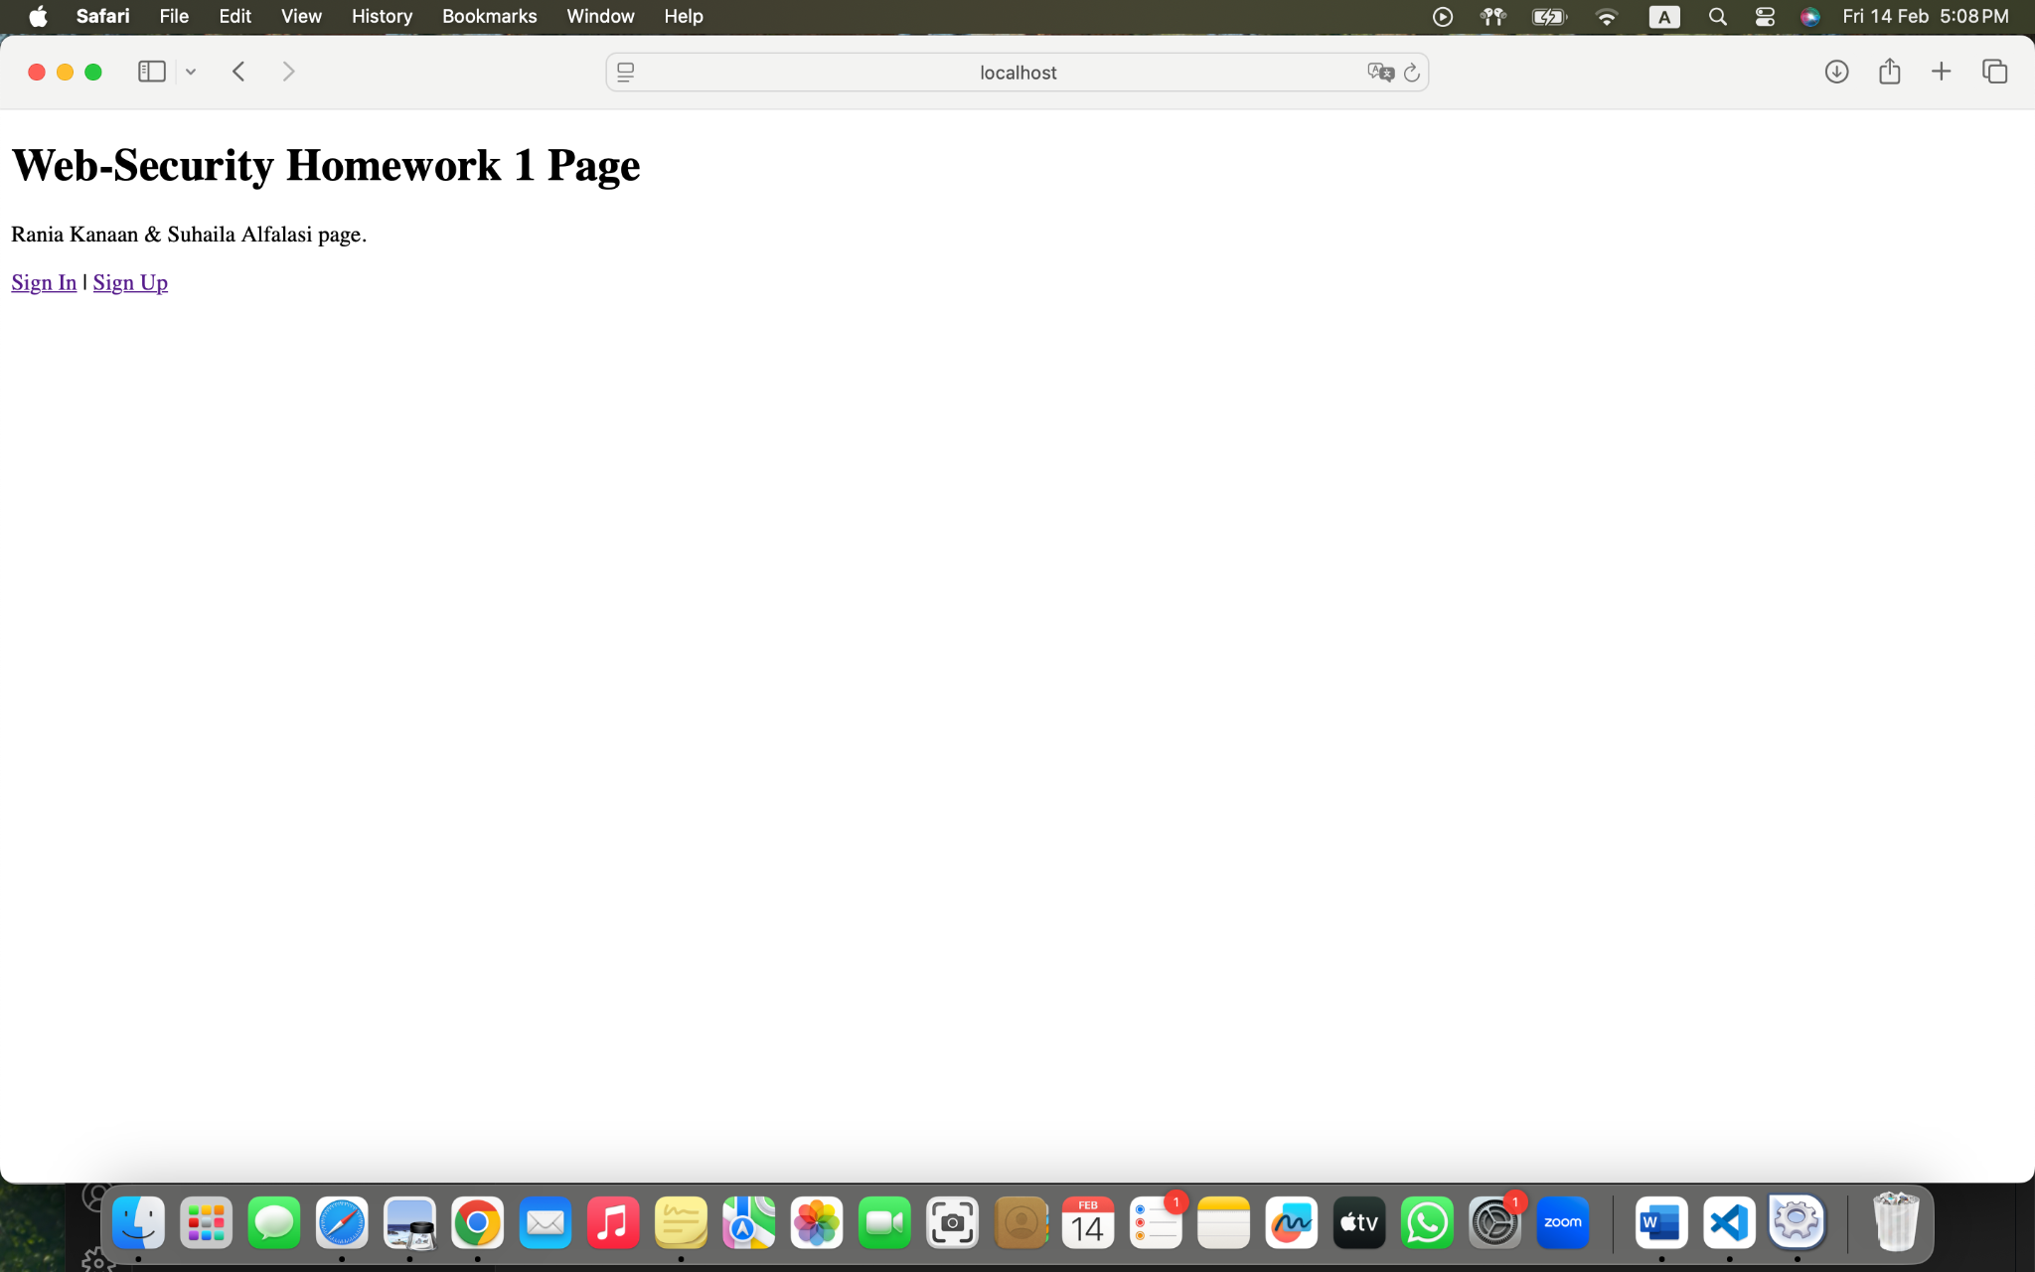Figure 37. Index Web Page

### Html code of the index page

<!DOCTYPE html>

<html>

<head>

<title>Homework 1</title>

</head>

<body>

<h1>Web-Security Homework 1 Page</h1>

<p>Rania Kanaan & Suhaila Alfalasi page.</p>

<a href="signin.html">Sign In</a> | <a href="signup.html">Sign Up</a>

</body>

</html>

### Sign In web page

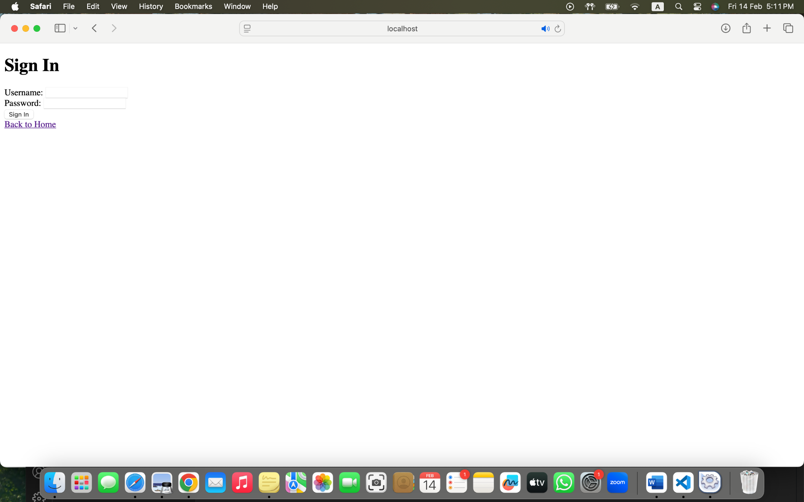

Figure 38. Sign In Web Page

### HTML code of Sign In page

<!DOCTYPE html>

<html>

<head>

<title>Sign In</title>

</head>

<body>

<h1>Sign In</h1>

<form>

<label>Username:</label>

<input type="text" name="username"><br>

<label>Password:</label>

<input type="password" name="password"><br>

<button type="submit">Sign In</button>

</form>

<a href="index.html">Back to Home</a>

</body>

</html>

### Sign Up web page

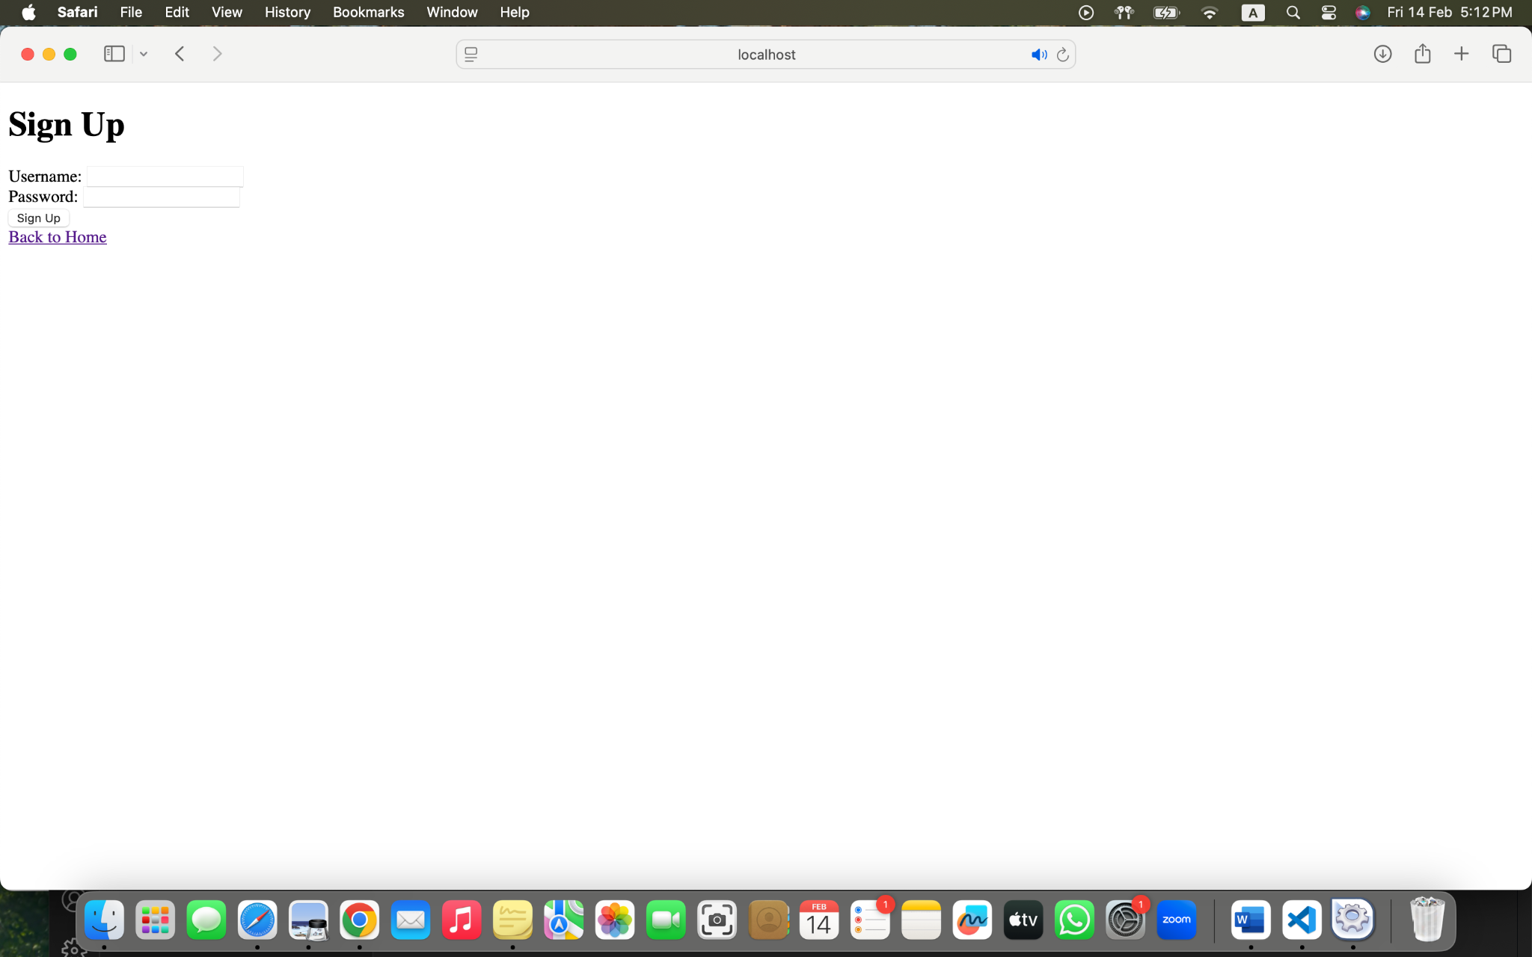

Figure 39. Sign Up Web Page

### HTML Code of Sign Up page

<!DOCTYPE html>

<html>

<head>

<title>Sign Up</title>

</head>

<body>

<h1>Sign Up</h1>

<form>

<label>Username:</label>

<input type="text" name="username"><br>

<label>Password:</label>

<input type="password" name="password"><br>

<button type="submit">Sign Up</button>

</form>

<a href="index.html">Back to Home</a>

</body>

</html>

### The GET and POST methods

The sign-in and sign-up pages require the GET and POST methods in order for the users can authenticate their access through user authentication. The GET method serves to request server-based delivery of login pages and registration pages. The URL becomes the channel to transport information making this method appropriate for data collection while remaining incapable of safe communication of sensitive data. Through the POST request, unlike the GET request, the user credentials and information will be able to be transmitted securely since POST does not show data through the URL it provides better security than GET for protecting sensitive data including passwords. Secure user authentication together with efficient account creation takes place because of this approach.

#### Signin.html GET method

<!DOCTYPE html>

<html>

<head>

<title>Sign In</title>

</head>

<body>

<h1>Sign In</h1>

<form action="signin.php" method="GET">

<label>Username:</label>

<input type="text" name="username"><br>

<label>Password:</label>

<input type="password" name="password"><br>

<button type="submit">Sign In</button>

</form>

<a href="index.html">Back to Home</a>

</body>

</html>

#### Signin.php

<?php

$username=$_GET['username'];

$password = $_GET['password'];

echo "Sign in Received:<br> Username: $username <br> Password: $password";

?>

<a href="index.html">Back to Home</a>

#### Signup.html POST method

<!DOCTYPE html>

<html>

<head>

<title>Sign Up</title>

</head>

<body>

<h1>Sign Up</h1>

<form action="signup.php" method="POST">

<label>Username:</label>

<input type="text" name="username"><br>

<label>Password:</label>

<input type="password" name="password"><br>

<button type="submit">Sign Up</button>

</form>

<a href="index.html">Back to Home</a>

</body>

</html>

#### Signup.php

<?php

$username=$_POST['username'];

$password = $_POST['password'];

echo "Sign up Received:<br> Username: $username <br> Password: $password";

?>

<a href="index.html">Back to Home</a>

## AI Generation of hypothetical website

With the usage of ChatGPT 4, it was able to generate a design for a skincare beauty page with a pink and purple theme for our three-page authentication system.It designed the three pages of the index, sign-in, and sign-up in order to match with the theme in order to ensure a visually appealing experience.Additionally, ChatGPT created an fourth page that would appear after the user sign in or sign up where the user can have a look at the different skin types and as well find the best makeup recommendations.

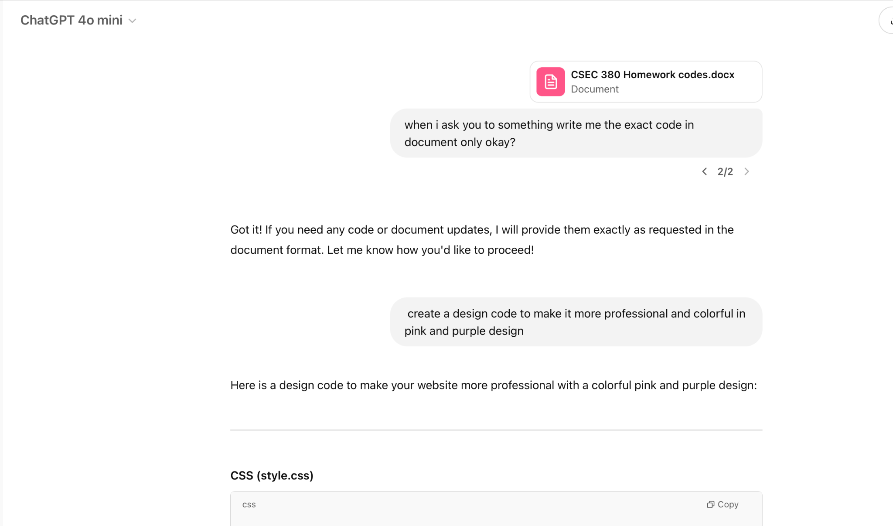

Figure 40. ChatGPT Design

### Style.css

/* General Styles */

body {

font-family: 'Poppins', sans-serif;

background: linear-gradient(180deg, #fce4ec, #f3e5f5);

color: #333;

text-align: center;

margin: 0;

padding: 0;

}

/* Header */

header {

background: linear-gradient(135deg, #ff8ba7, #d7a1e5);

color: white;

padding: 30px;

}

h1 {

font-size: 2.5em;

}

/* Buttons */

.button, form button {

padding: 12px 20px;

font-size: 1.2em;

color: white;

background: linear-gradient(135deg, #5c4d7d, #9c89b8);

border: none;

border-radius: 8px;

cursor: pointer;

transition: transform 0.3s ease-in-out;

margin-top: 20px;

}

.button:hover, form button:hover {

transform: scale(1.05);

background: linear-gradient(135deg, #9c89b8, #d7a1e5);

}

/* Image Gallery */

.image-gallery {

display: flex;

justify-content: center;

gap: 20px;

margin: 30px 0;

}

.image-gallery img {

width: 200px;

height: auto;

border-radius: 10px;

box-shadow: 0 4px 15px rgba(0, 0, 0, 0.1);

}

/* Footer */

footer {

background: #5c4d7d;

color: white;

padding: 20px;

}

### Index.html web page

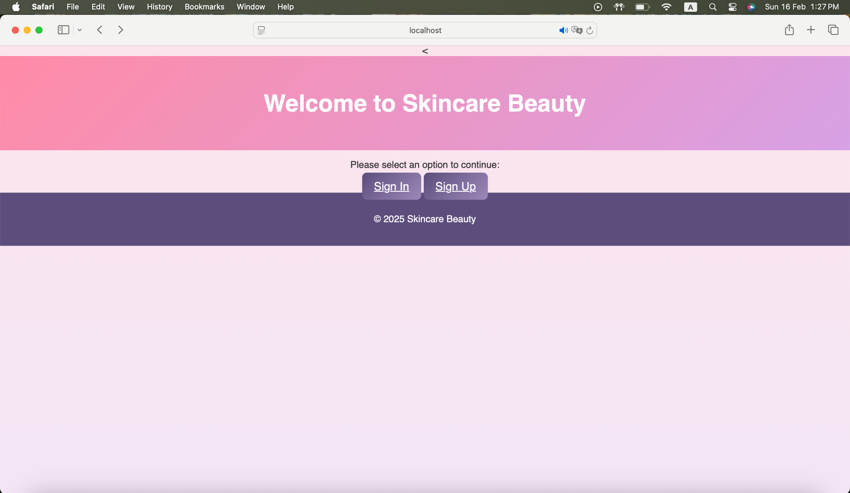

Figure 41. Welcome Page

### Index.html Code

<<!DOCTYPE html>

<html lang="en">

<head>

<meta charset="UTF-8">

<meta name="viewport" content="width=device-width, initial-scale=1.0">

<title>Welcome to Skincare Beauty</title>

<link rel="stylesheet" href="style.css">

</head>

<body>

<header>

<h1>Welcome to Skincare Beauty</h1>

<p>Here we will let you find your best Foundation option</p>

</header>

<main>

<p>Please select an option to continue:</p>

<div class="button-container">

<a href="signin.html" class="button">Sign In</a>

<a href="signup.html" class="button">Sign Up</a>

</div>

<div class="image-container">

<img src="images/best.jpg" alt="Foundation Image">

</div>

</main>

<footer>

<p>&copy; 2025 Skincare Beauty</p>

</footer>

</body>

</html>

### Signin.html web page

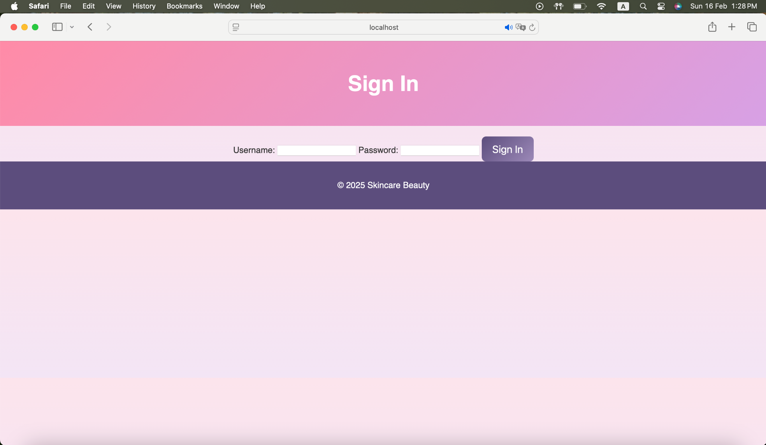

Figure 42. Sign In Page

### Signin.html code

<!DOCTYPE html>

<html lang="en">

<head>

<meta charset="UTF-8">

<meta name="viewport" content="width=device-width, initial-scale=1.0">

<title>Sign In</title>

<link rel="stylesheet" href="style.css">

</head>

<body>

<header>

<h1>Sign In</h1>

</header>

<main>

<form action="signin.php" method="GET">

<label for="username">Username:</label>

<input type="text" id="username" name="username" required>

<label for="password">Password:</label>

<input type="password" id="password" name="password" required>

<button type="submit">Sign In</button>

</form>

</main>

<footer>

<p>&copy; 2025 Skincare Beauty</p>

</footer>

</body>

</html>

### Signin.php code

<?php

if ($_SERVER["REQUEST_METHOD"] == "GET") {

$username = $_GET['username'];

$password = $_GET['password'];

echo "<script>

alert('Sign in received:\\nUsername: $username\\nPassword: $password');

window.location.href = 'welcome.html';

</script>";

}

?>

### Signup.html web page

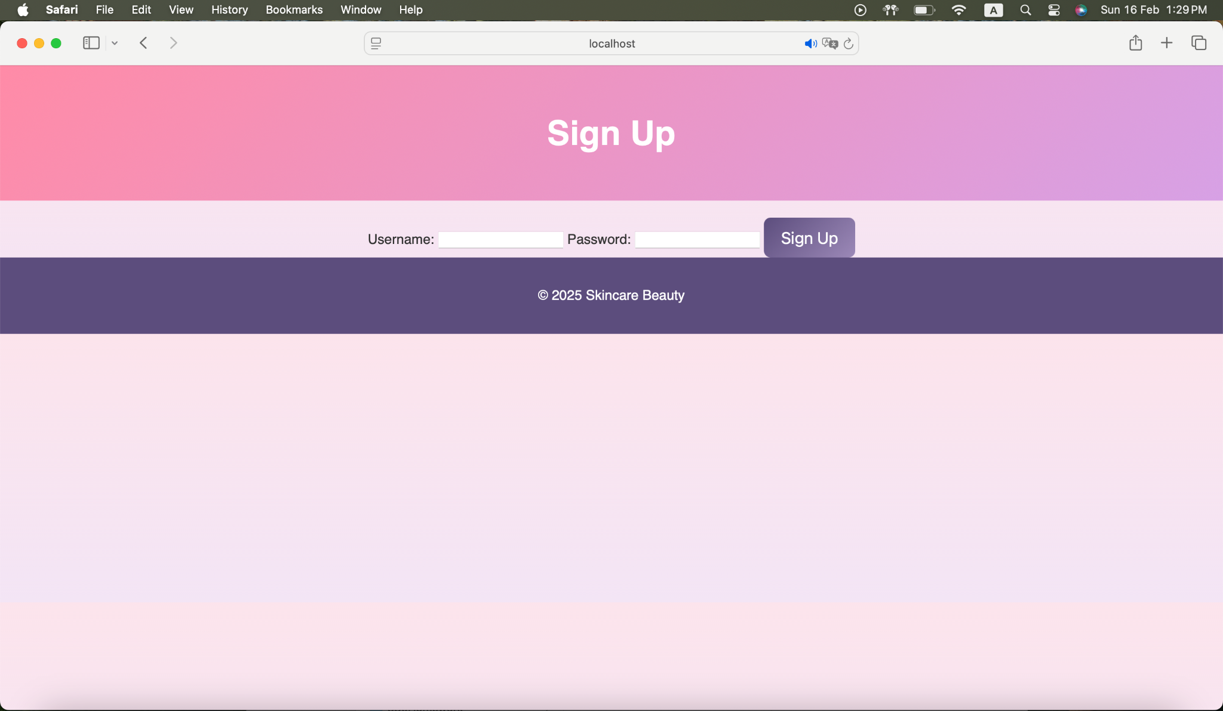

Figure 43. Sign Up Page

### Signup.html code

<!DOCTYPE html>

<html lang="en">

<head>

<meta charset="UTF-8">

<meta name="viewport" content="width=device-width, initial-scale=1.0">

<title>Sign Up</title>

<link rel="stylesheet" href="style.css">

</head>

<body>

<header>

<h1>Sign Up</h1>

</header>

<main>

<form action="signup.php" method="POST">

<label for="username">Username:</label>

<input type="text" id="username" name="username" required>

<label for="password">Password:</label>

<input type="password" id="password" name="password" required>

<button type="submit">Sign Up</button>

</form>

</main>

<footer>

<p>&copy; 2025 Skincare Beauty</p>

</footer>

</body>

</html>

### Signup.php code

<?php

if ($_SERVER["REQUEST_METHOD"] == "POST") {

$username = $_POST['username'];

$password = $_POST['password'];

echo "<script>

alert('Sign up received:\\nUsername: $username\\nPassword: $password');

window.location.href = 'welcome.html';

</script>";

}

?>

### Welcome.html web page

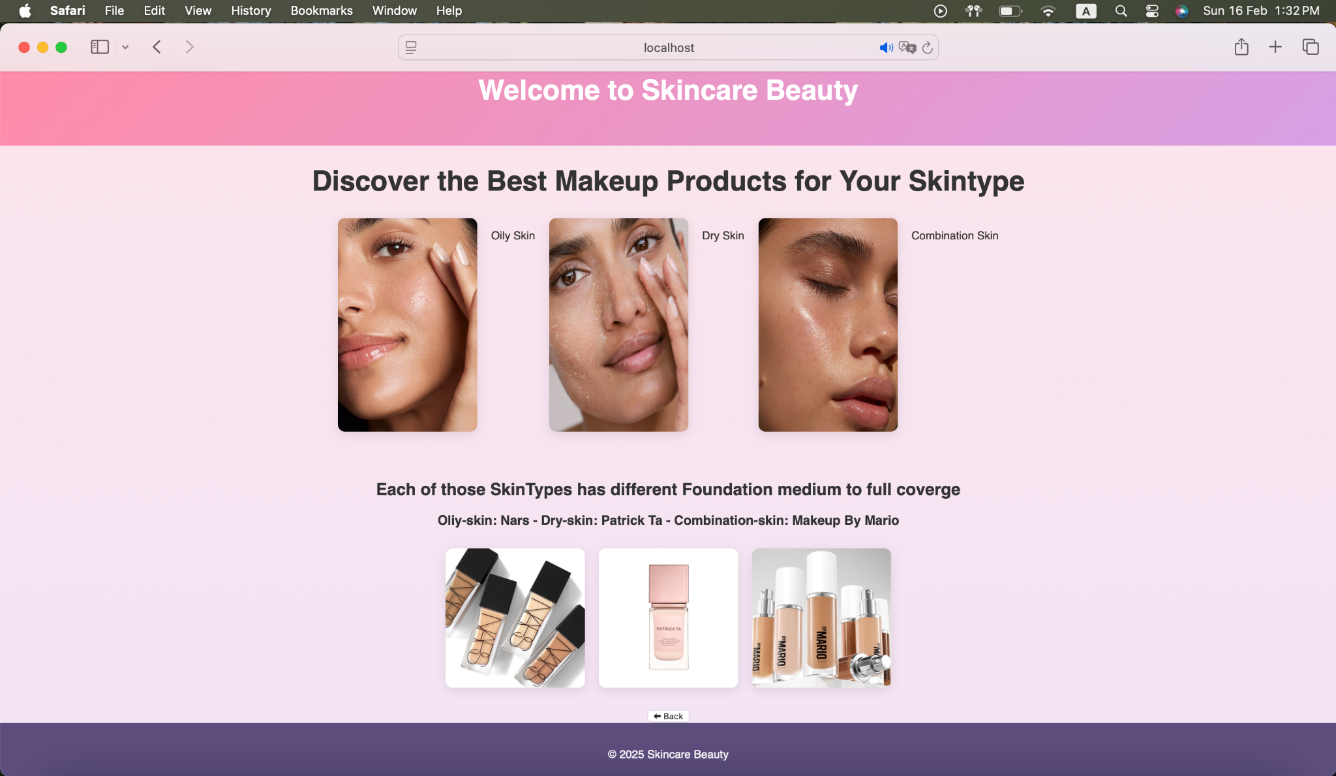

Figure 44. Skincare Beauty Page

### Welcome.html code

<!DOCTYPE html>

<html lang="en">

<head>

<meta charset="UTF-8">

<meta name="viewport" content="width=device-width, initial-scale=1.0">

<title>Welcome</title>

<link rel="stylesheet" href="style.css">

</head>

<body>

<header>

<h1>Welcome to Skincare Beauty</h1>

</header>

<main>

<h1>Discover the Best Makeup Products for Your Skintype</h1>

<div class="image-gallery">

<img src="images/Oilyskin.jpg" alt="Oily">

<p>Oily Skin</p>

<img src="images/Dryskin.jpg" alt="Dry">

<p>Dry Skin</p>

<img src="images/combinationskin.jpg" alt="combination">

<p>Combination Skin</p>

</div>

<br>

<h2>Each of those SkinTypes has different Foundation medium to full coverge</h2>

<h3>Oliy-skin: Nars - Dry-skin: Patrick Ta - Combination-skin: Makeup By Mario</h3>

<div class="image-gallery">

<img src="images/Nars.jpg" alt="For Oily skin: is NARS Foundation">

<img src="images/Patrick.jpg" alt="For Dry skin: is Patrick Ta Foundation">

<img src="images/Mario.jpg" alt="For Combination skin: is Makeup By Mario Foundation">

</div>

<button class="back-button" onclick="history.back()">⬅ Back</button>

</main>

<footer>

<p>&copy; 2025 Skincare Beauty</p>

</footer>

</body>

</html>

# 

# Attacks

## Burp Suite Attack

### Changing the hostname to [www.google.com](http://www.google.com).

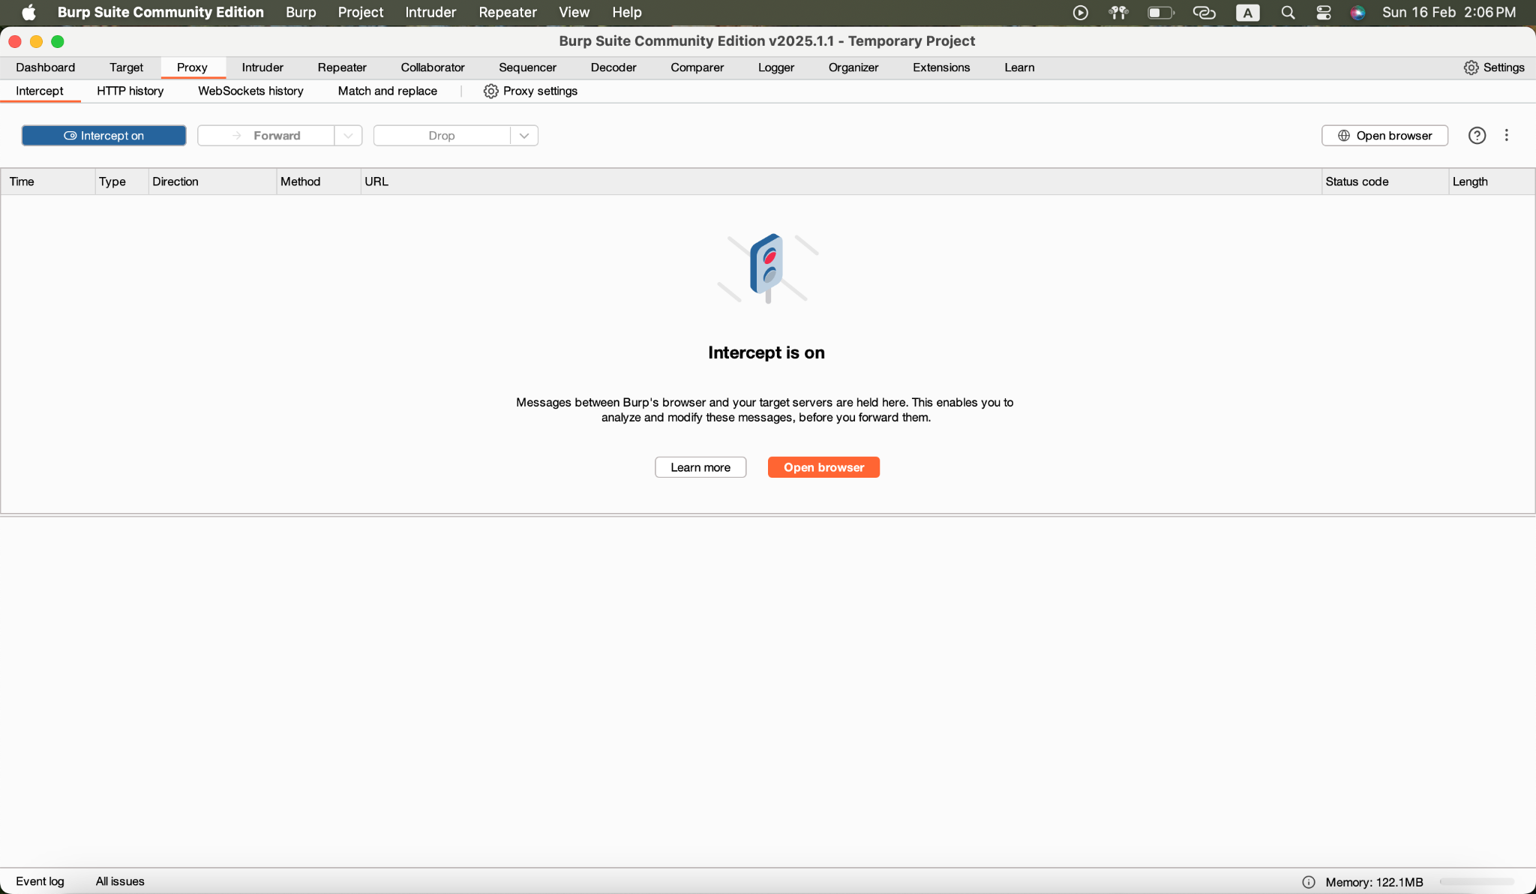

Figure 45. Proxy Intercept ON

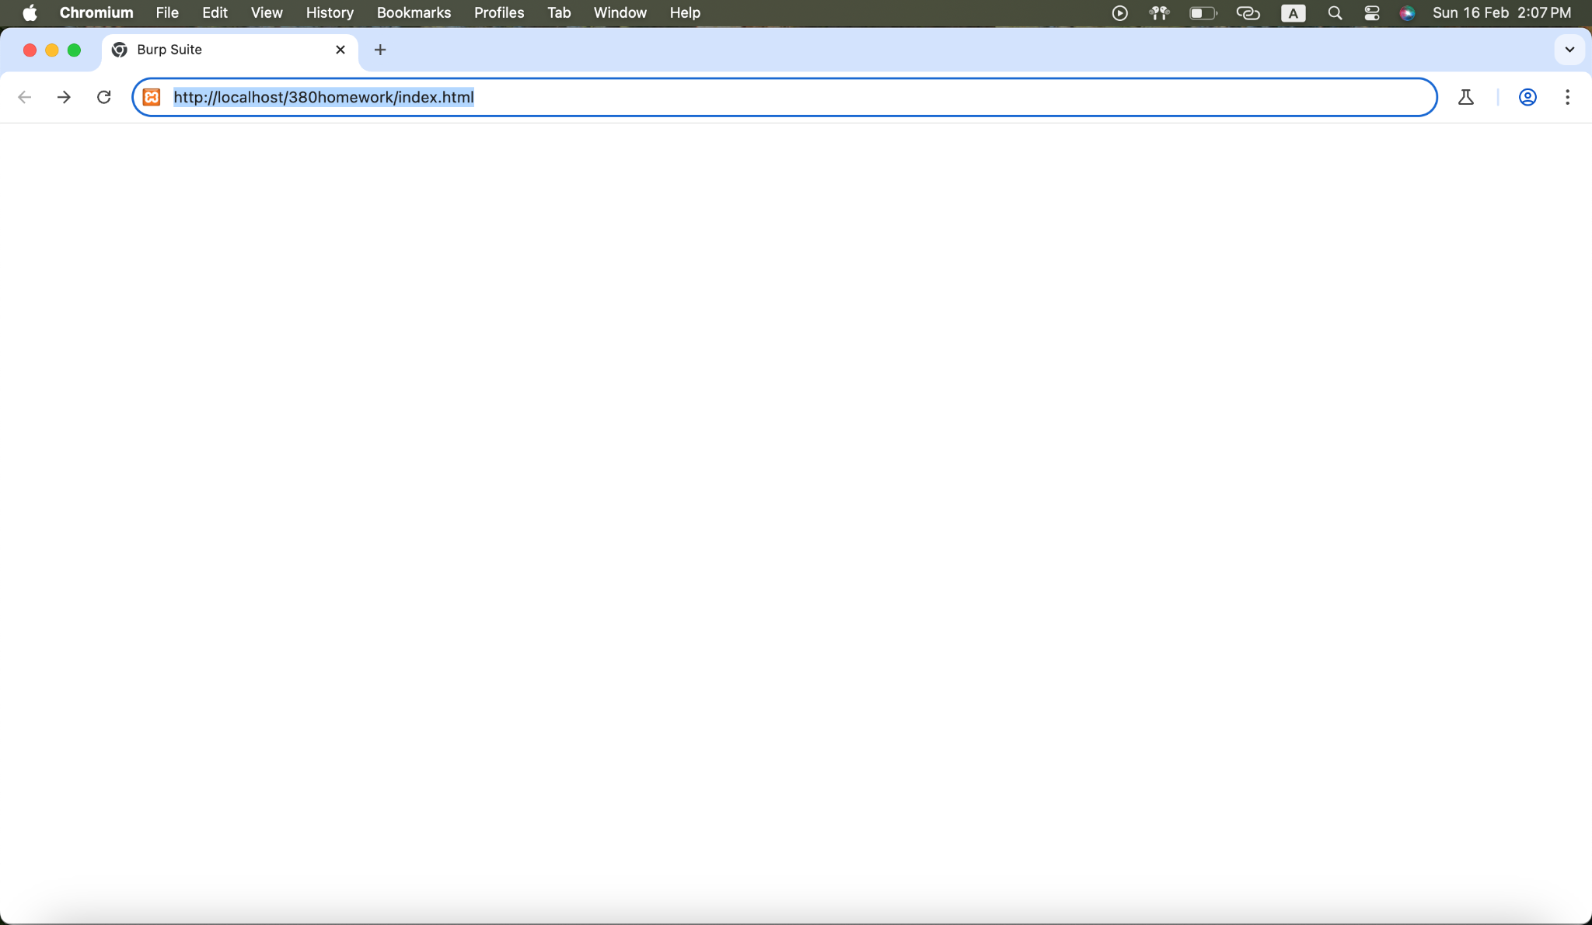

Figure 46. Entering the File Path

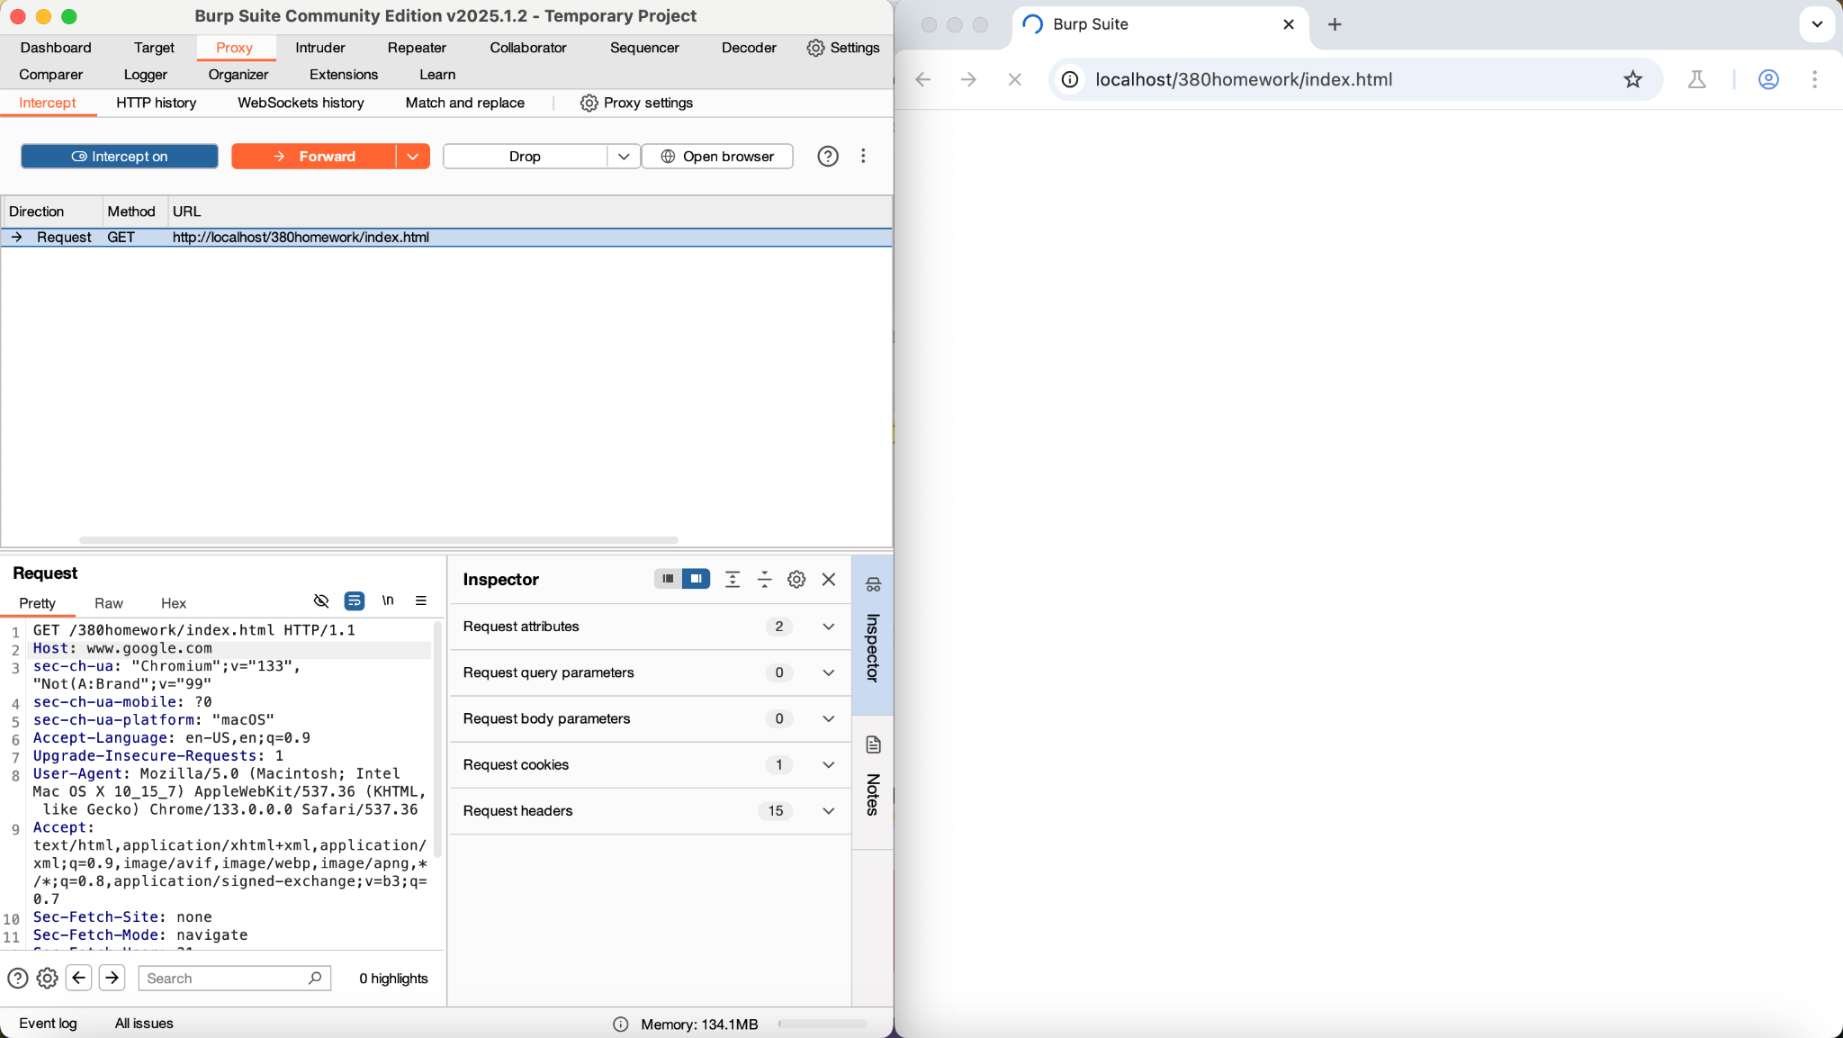

Figure 47. Changing the hostname

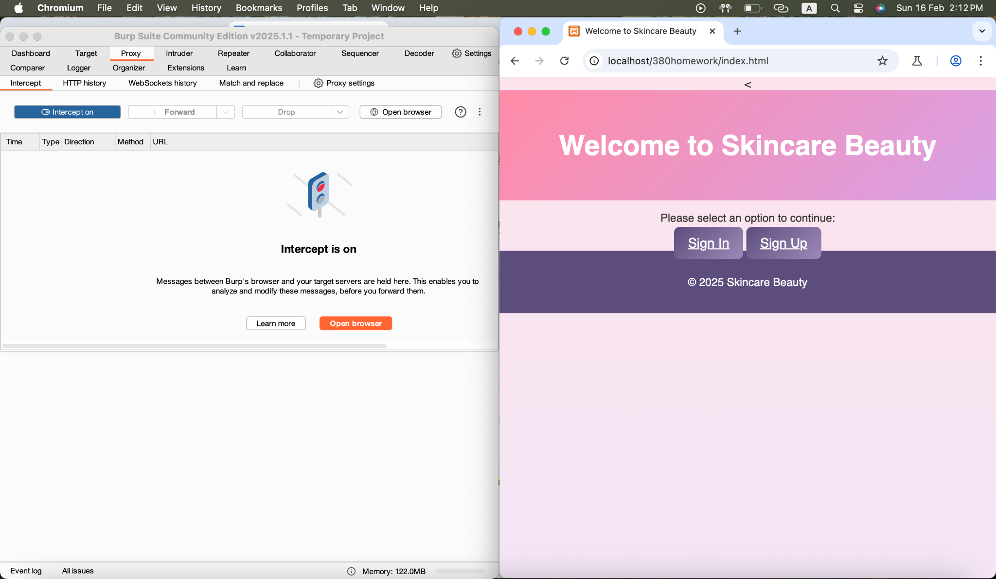

Figure 48. Forward the Request

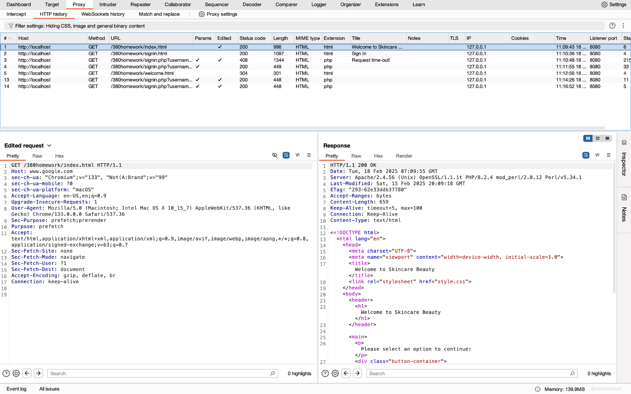

Figure 49. Successful Request

In Burp Suite, when applying the change of the hostname from "localhost" to ‘[www.google.com](http://www.google.com)’ in an HTTP request, this is considered a host header manipulation attack. This attack happens when the attacker modifies the `Host` header in the request to a different domain instead of the target original domain. Depending on how the server processes the ‘Host’ header that could lead to different effects. If the server depends on the `Host` header in order to determine the destination or to determine the routing requests, then it might forward the request to "www.google.com" or process the request as if it were intended for that domain. This could lead to several issues such as, server-side request forgery, cache poisoning, bypassing the security controls, or it could lead to exposing sensitive data. A proper validation process of the `Host` headers must be established to overcome these problems.

### Adding additional nonstandard headers and different HTTP versions to the GET requests.

#### Modifying the username and Password

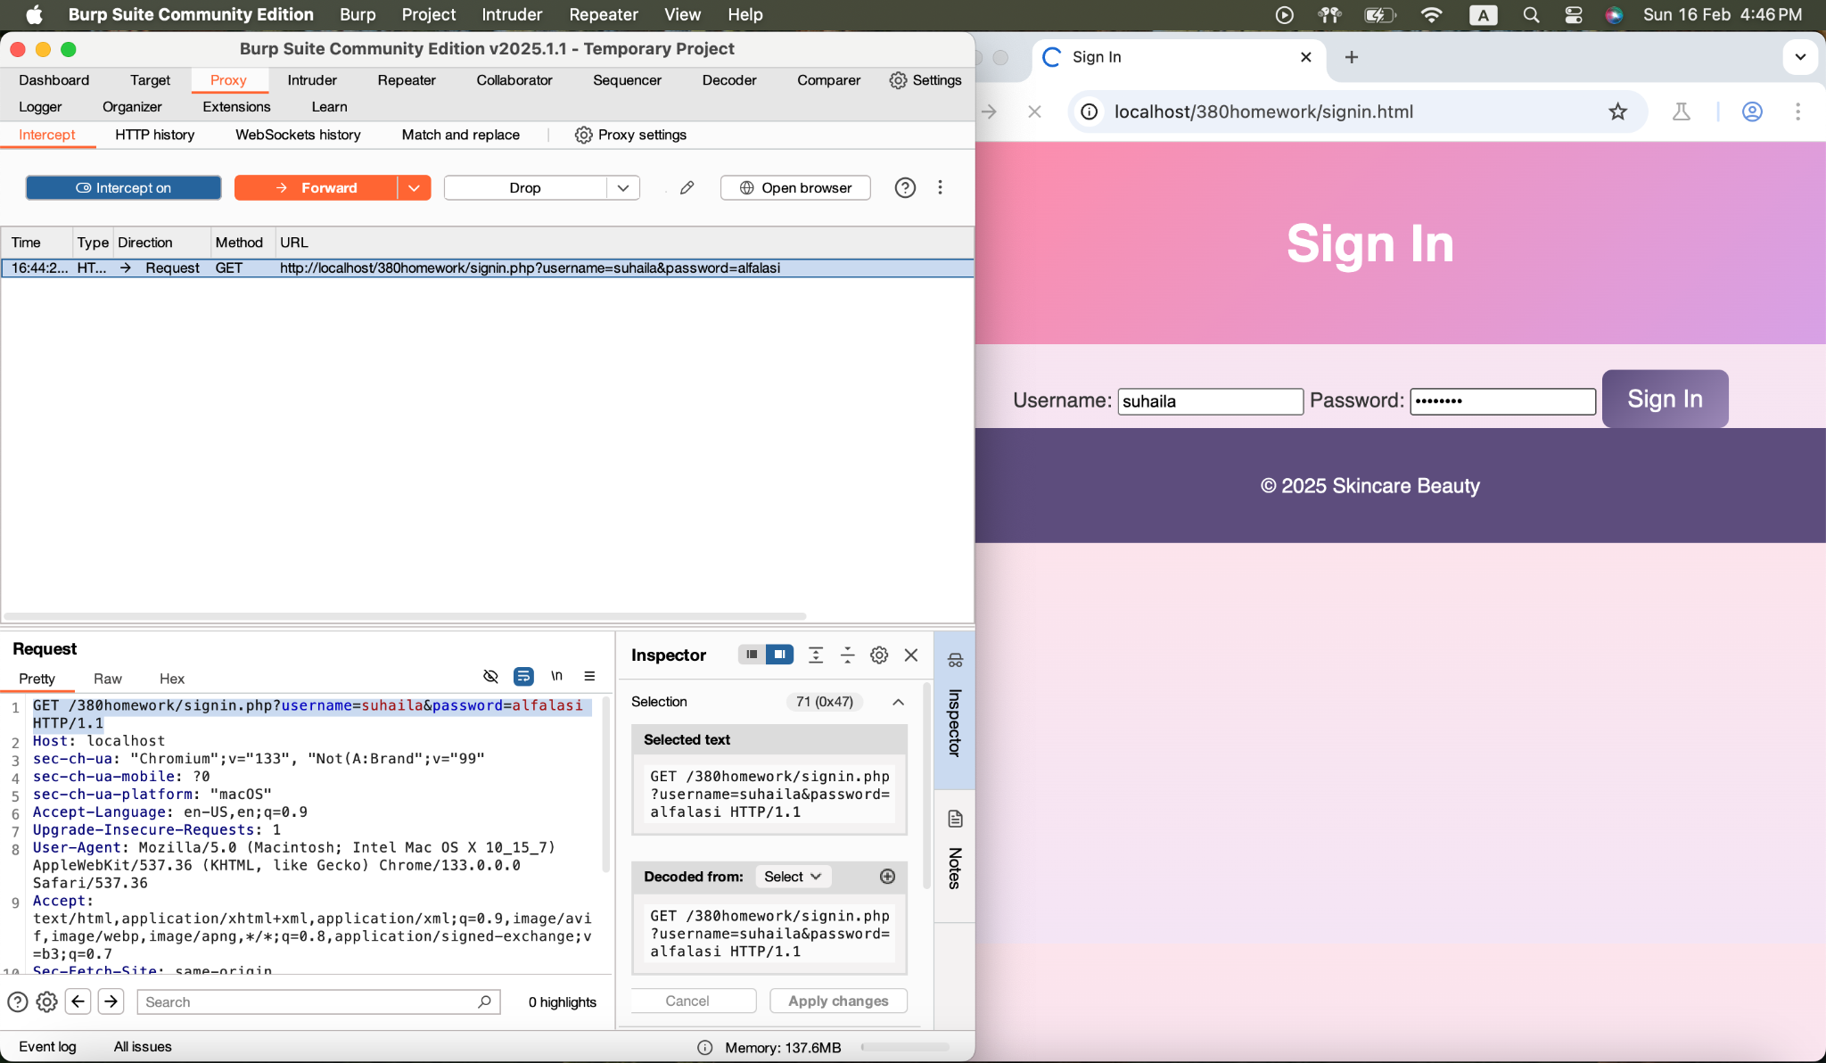

Figure 50. Entering the Username and Password

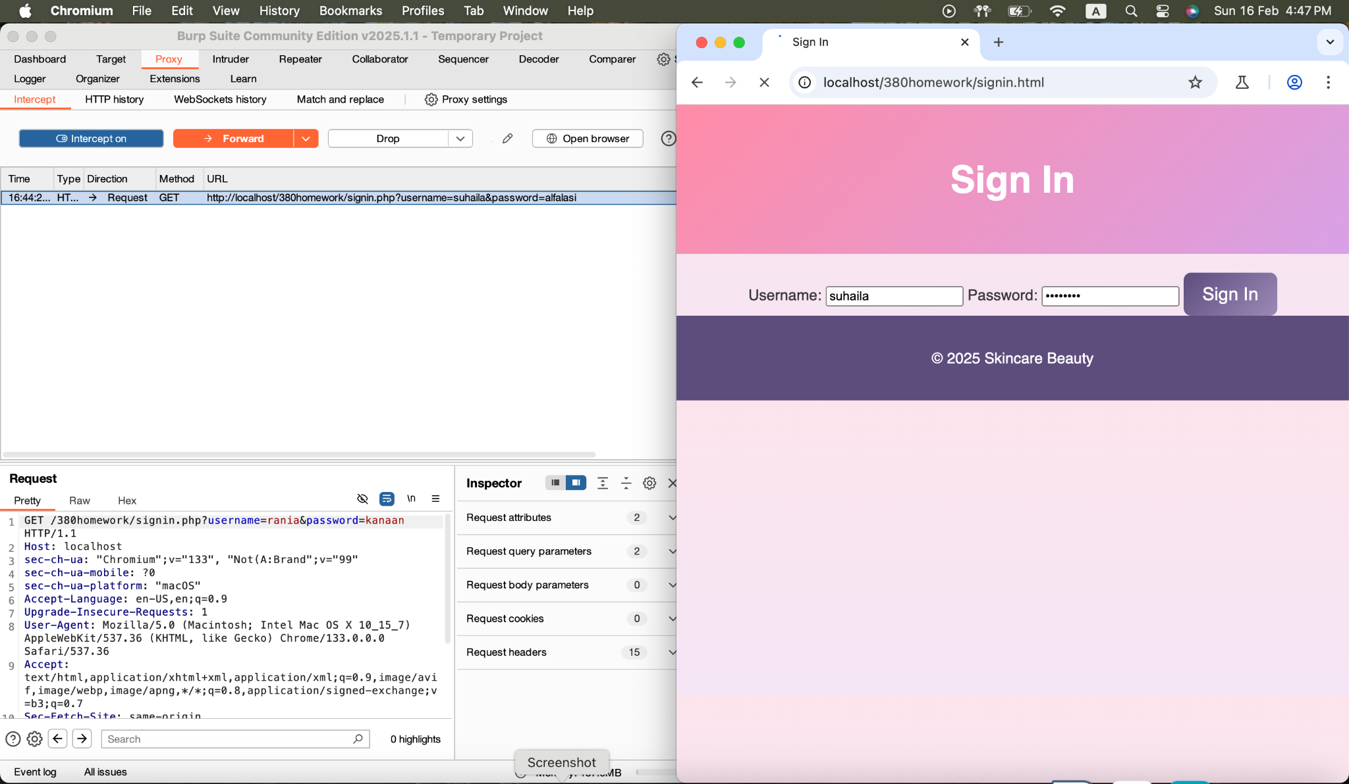

Figure 51. Changing the Username and Password

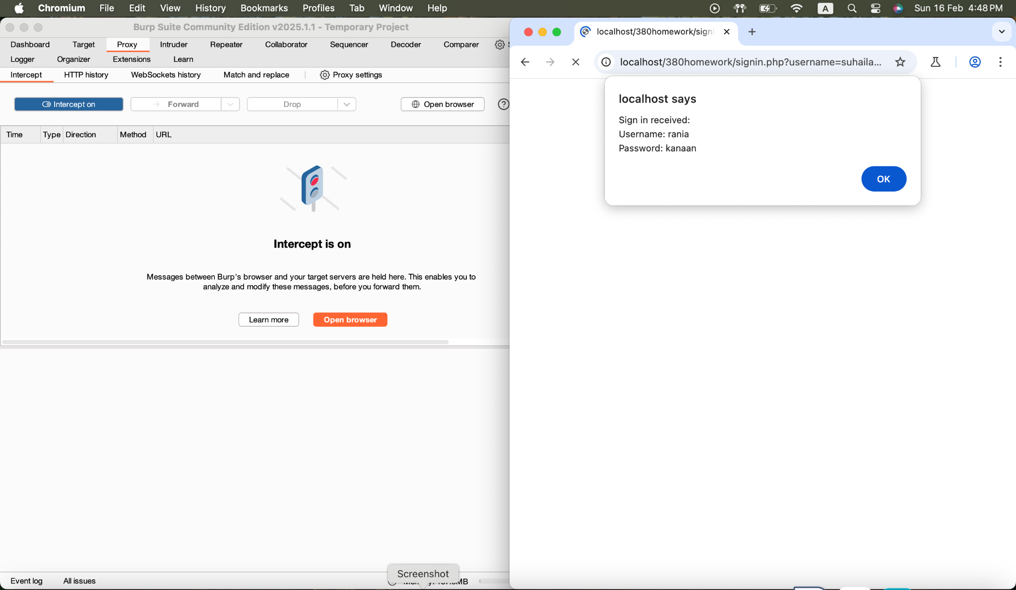

Figure 52. Confirmation of the Change

In Burp Suite, when entering the username as "suhaila" and the password as "alfalasi" and clicked on the "Sign In" button, the request was captured in Burp Suite where the attack is able to altered the username to "rania" and the password to "kanaan" before forwarding it. These changes were successfully forwarded where the server was able to process it with the altered credentials.

#### Adding Header of IP Address Modification

<?php

if ($_SERVER["REQUEST_METHOD"] == "GET") {

$username = $_GET['username'];

$password = $_GET['password'];

$ip_address = isset($_SERVER['HTTP_X_FORWARDED_FOR']) ? $_SERVER['HTTP_X_FORWARDED_FOR'] : $_SERVER['REMOTE_ADDR'];

echo "<script>

alert('Sign in received:\\nUsername: $username\\nPassword: $password\\nIP Address: $ip_address');

window.location.href = 'welcome.html';

</script>";

}

?>

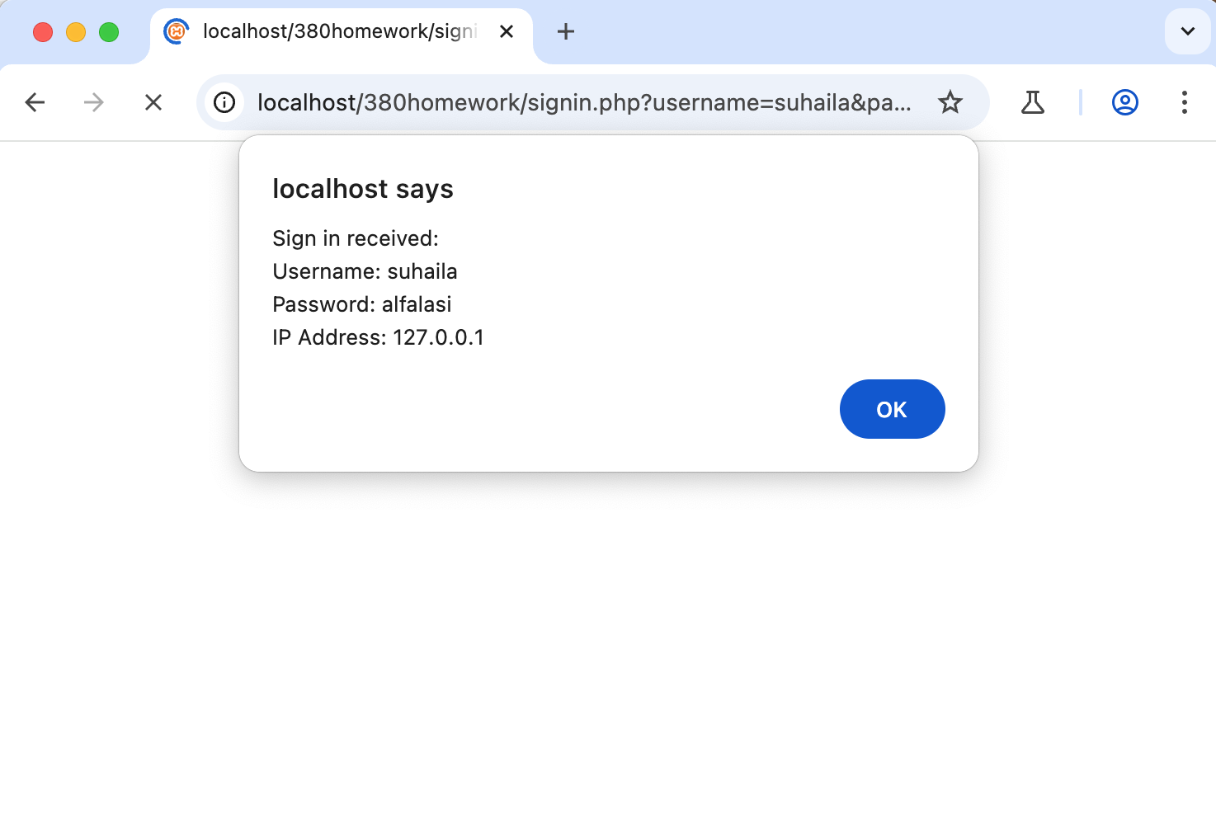

Figure 53. IP Address of Localhost

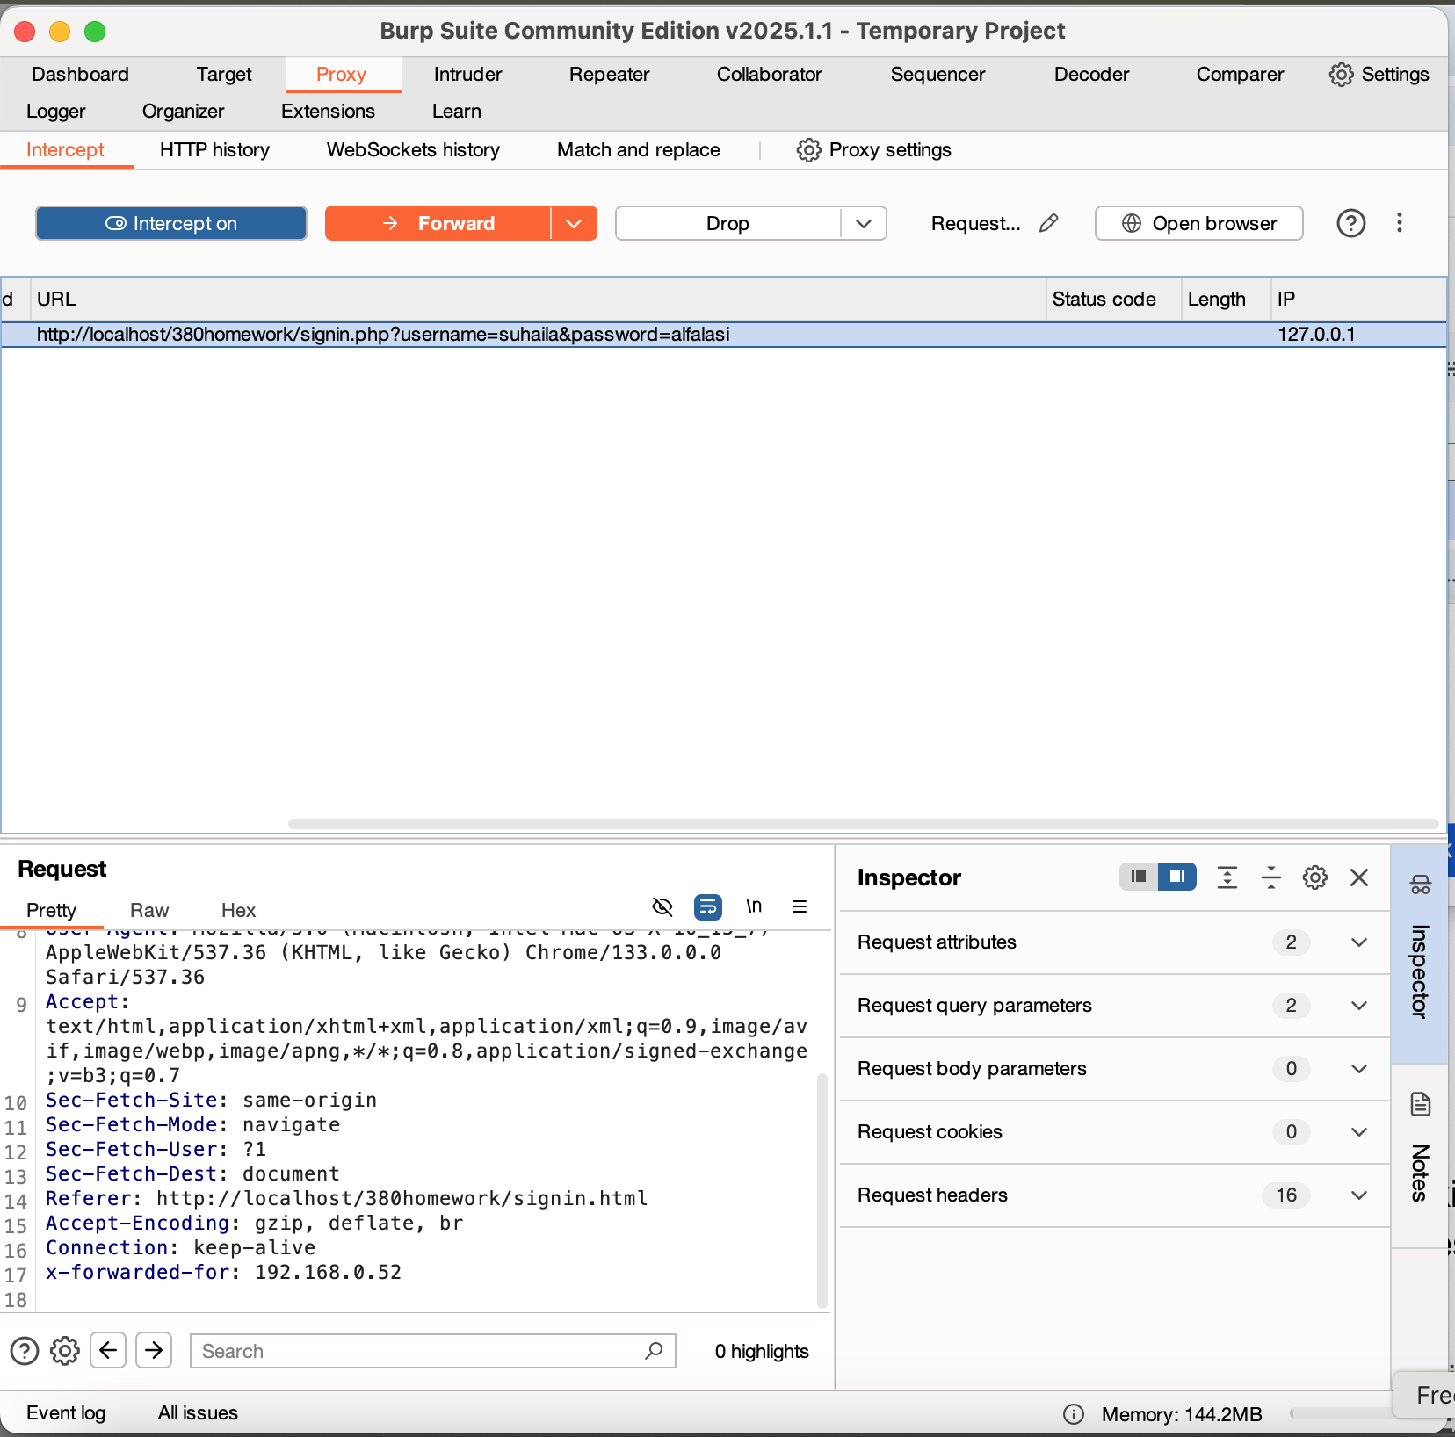

Figure 54. Changing IP Address of Localhost

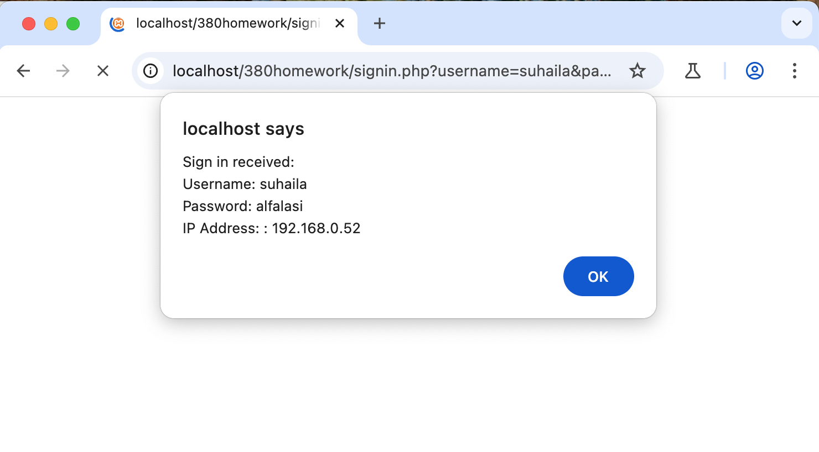

Figure 55. Confirmation of the IP Address Change

Signin.php code includes an extra code that displays user IP addresses. After forwarding the request, a popup message appeared with the username and password entered along with an IP address of the localhost. Through Burp Suite, the addition of ‘X-Forwarded-For’ header is used to modify the IP address of the ‘localhost’ from ‘127.0.0.1’ to ‘192.168.0.52’ where the server accepted the altered IP address leading to display of the fake IP in the popup. Header manipulation allows attackers to spoof their IP address and such behavior would both avoid IP-based restrictions as well as logging mechanisms if server fails to validate the header.

#### Adding an Extra Header

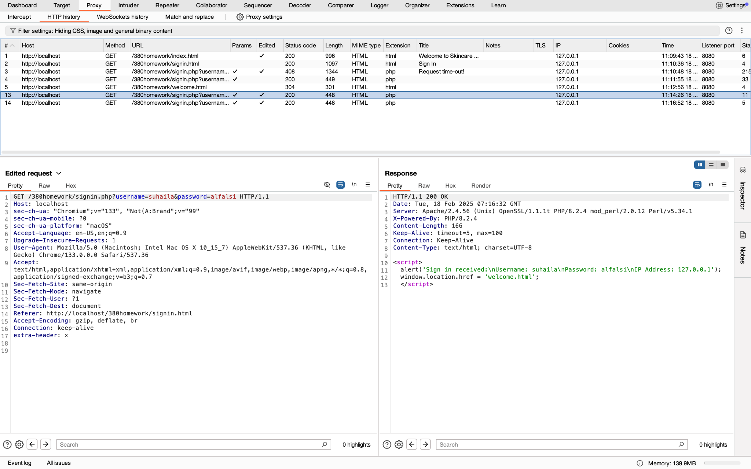

Figure 56. Adding Extra Header

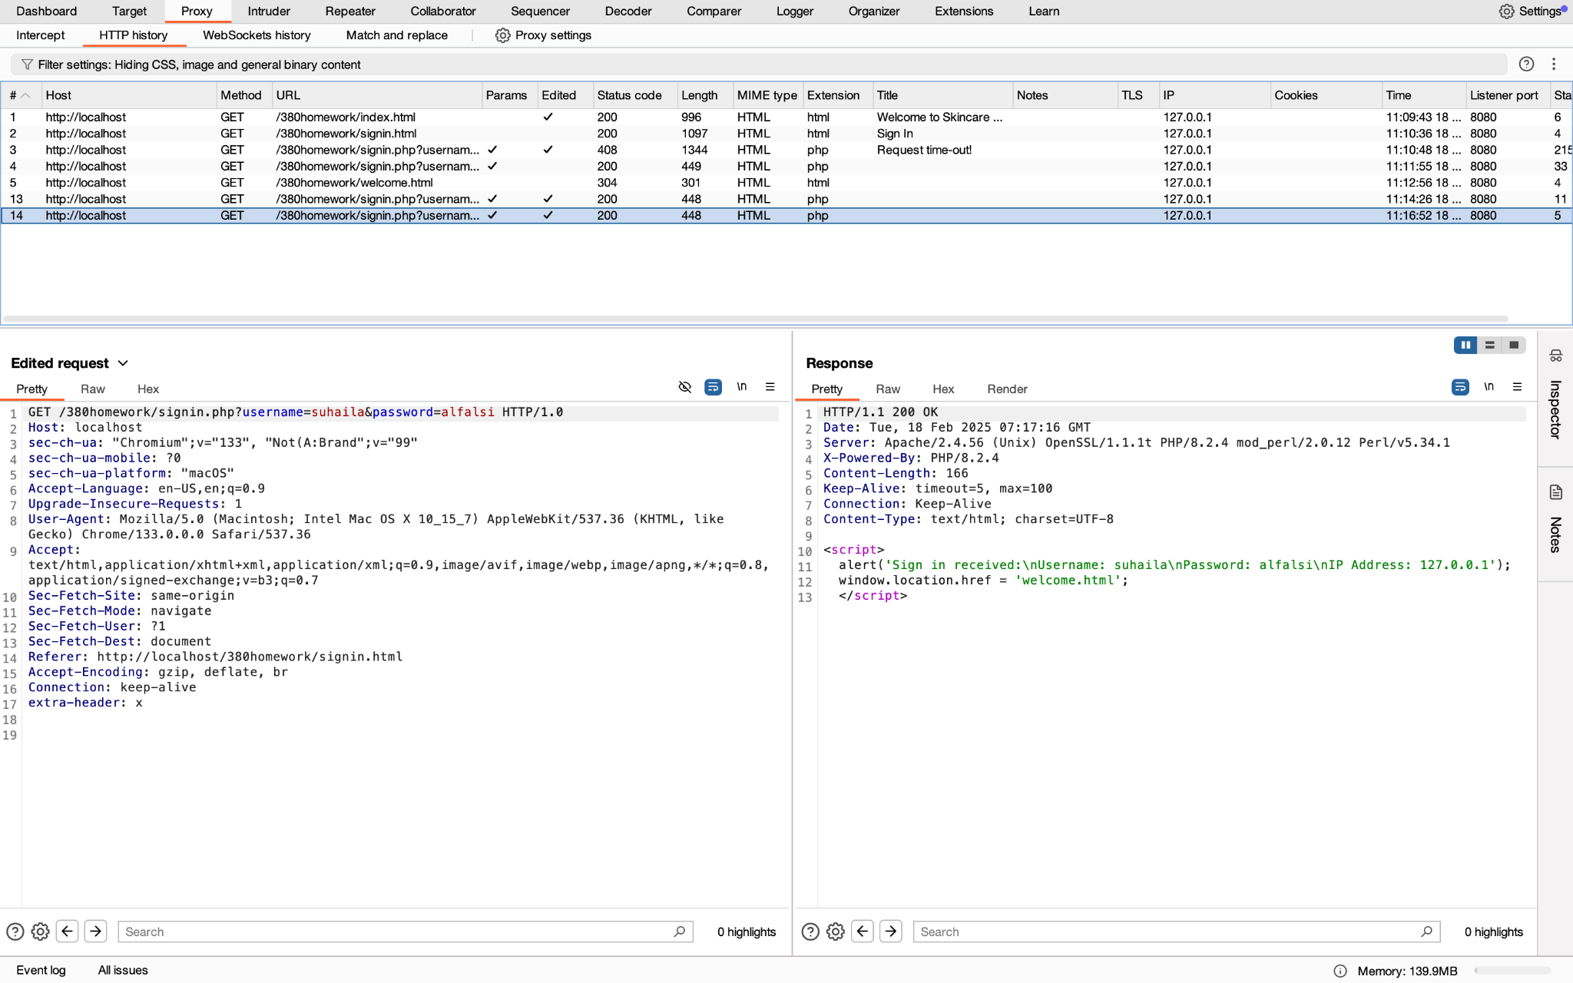

Figure 57. Changing HTTP Version

When testing with a GET request, the addition nonstandard headers such as ‘extra-header: x’ when tested on different HTTP versions (HTTP/1.0 and HTTP/1.1) shows that both versions have been successfully processed the request. Attackers prefer HTTP/1.0 instead of HTTP/1.1 because it is an older version that lacks some of the requirements found in HTTP/1.1. By the usage of HTTP/1.0, the attack would be able to bypass security mechanisms.

### Change the POST request to GET request

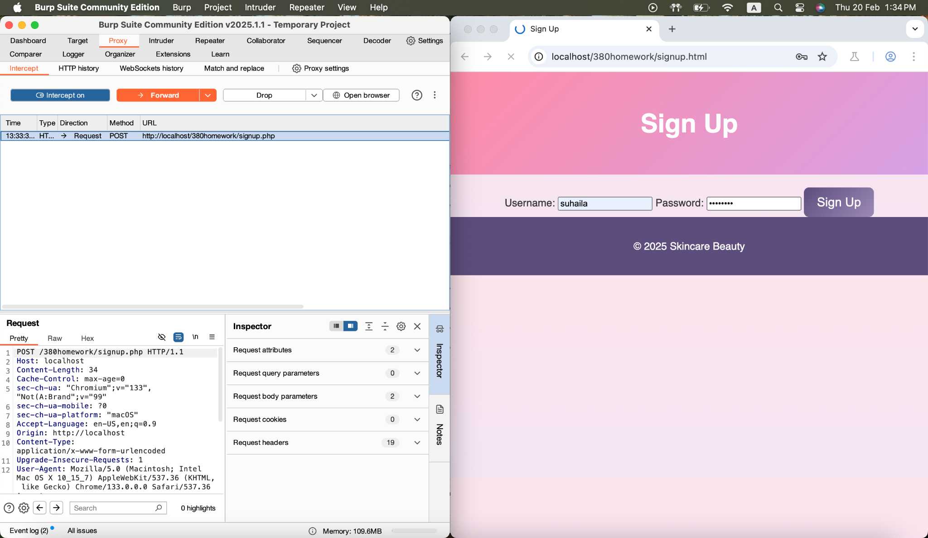

Figure 58. Original POST Request

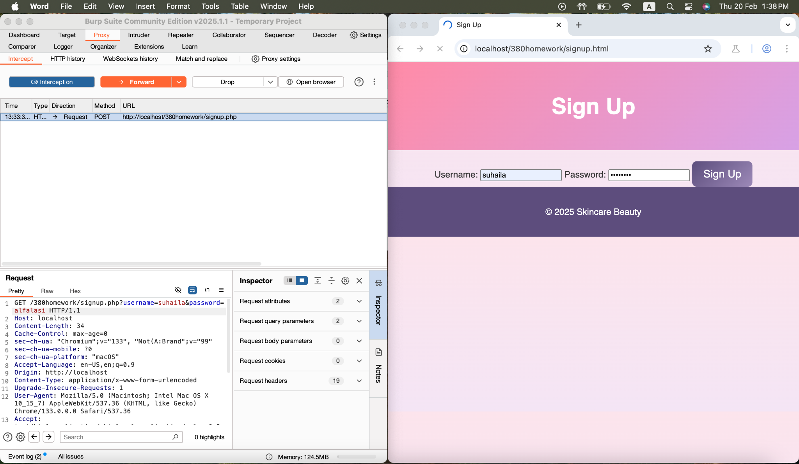

Figure 59. Change to GET Request

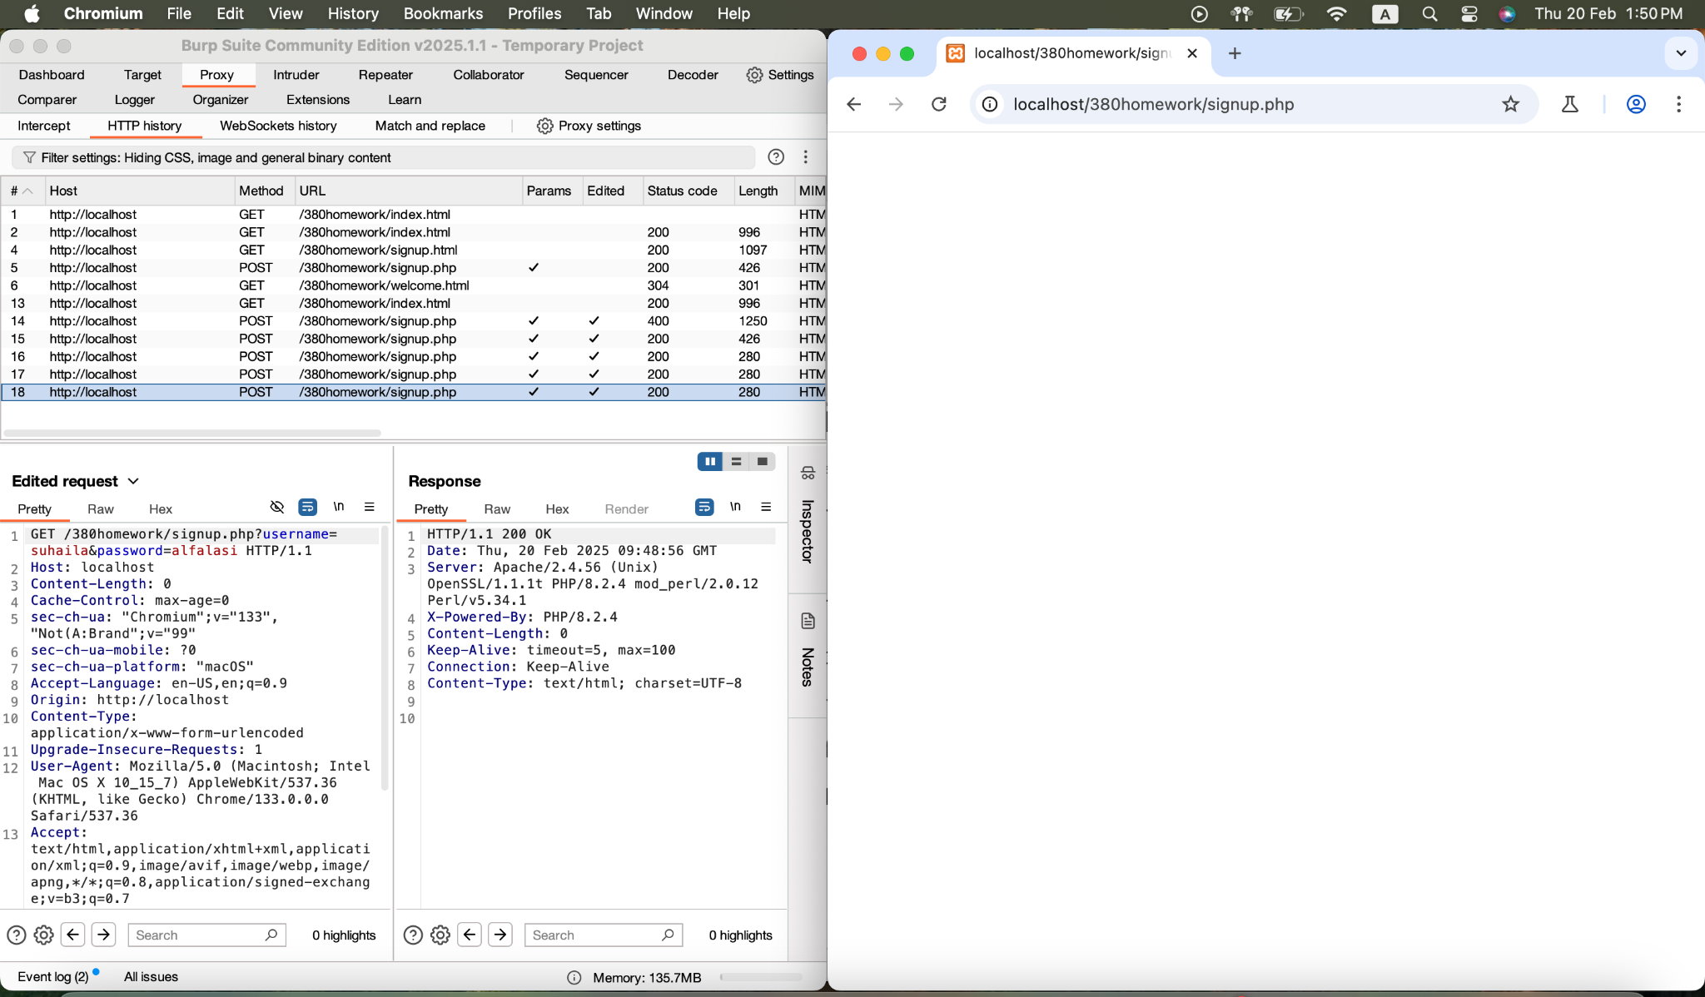

Figure 60. Forward the Change

When changing the request from POST to GET and adding the username and password parameters, it would not go through and that is because GET sends data in the URL, while POST sends it in the request body. Servers often expect login credentials in the body for security reasons, when switching to GET it would cause the server to reject the request.

## Owasp ZAP Attack

### a. Setting the Cookie and intercepting the request and adding additional headers such as HTTPOnly, Secure, Expiration Date, and Path.

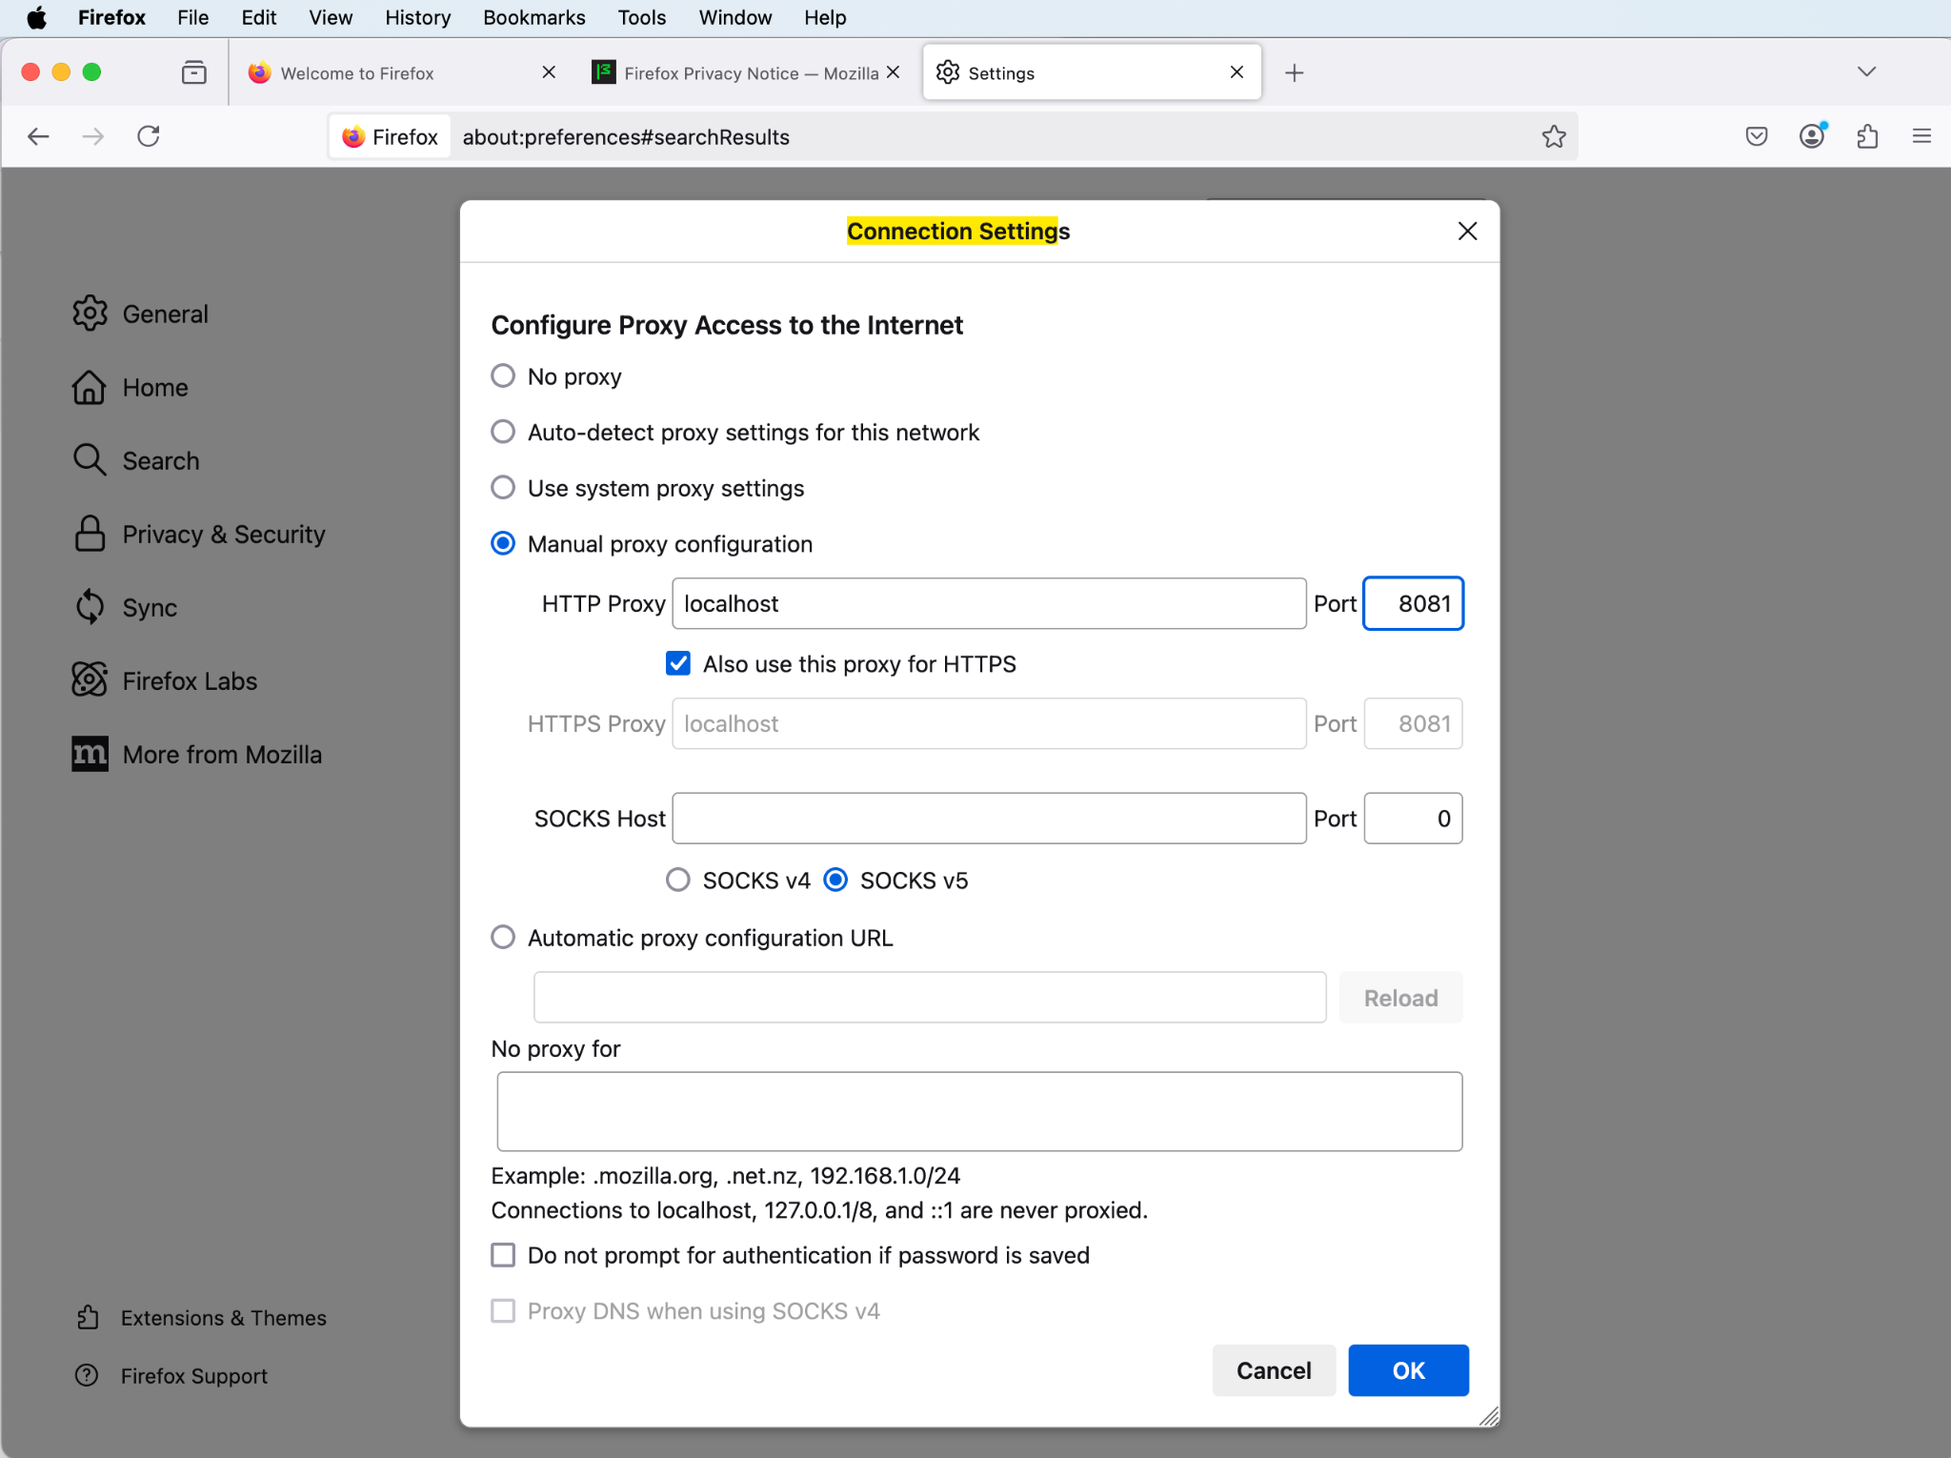

Figure 61. Firefox Connection Setting

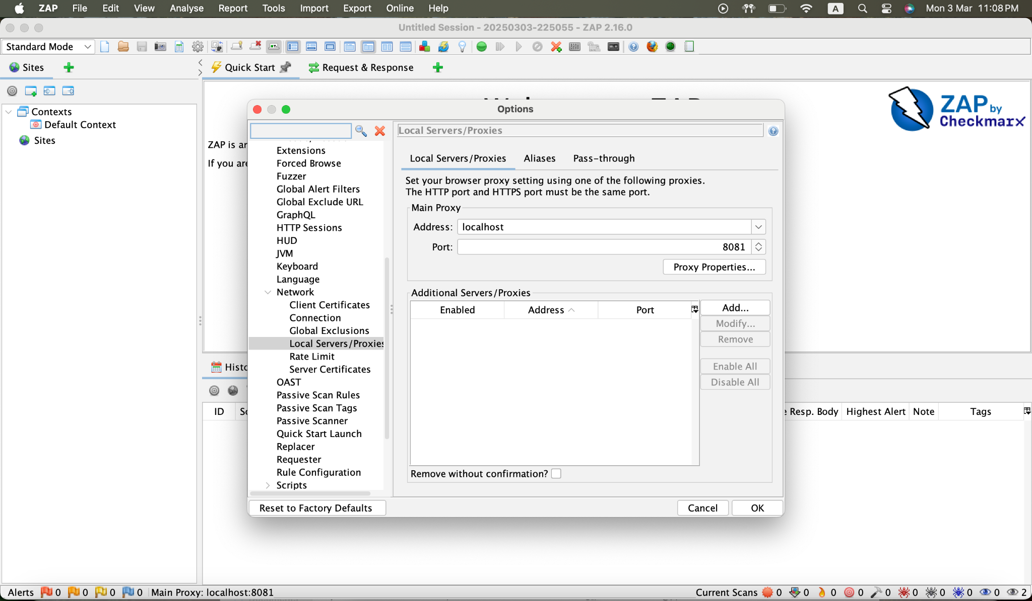

Figure 62. ZAP Proxy Setting

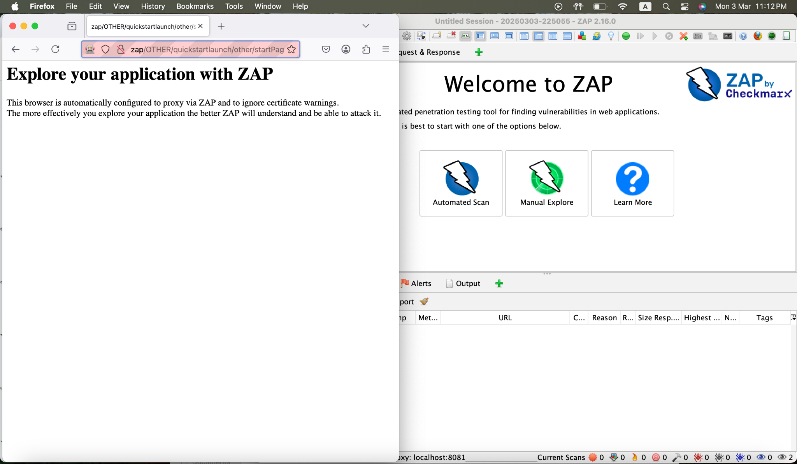

Figure 63. ZAP Firefox

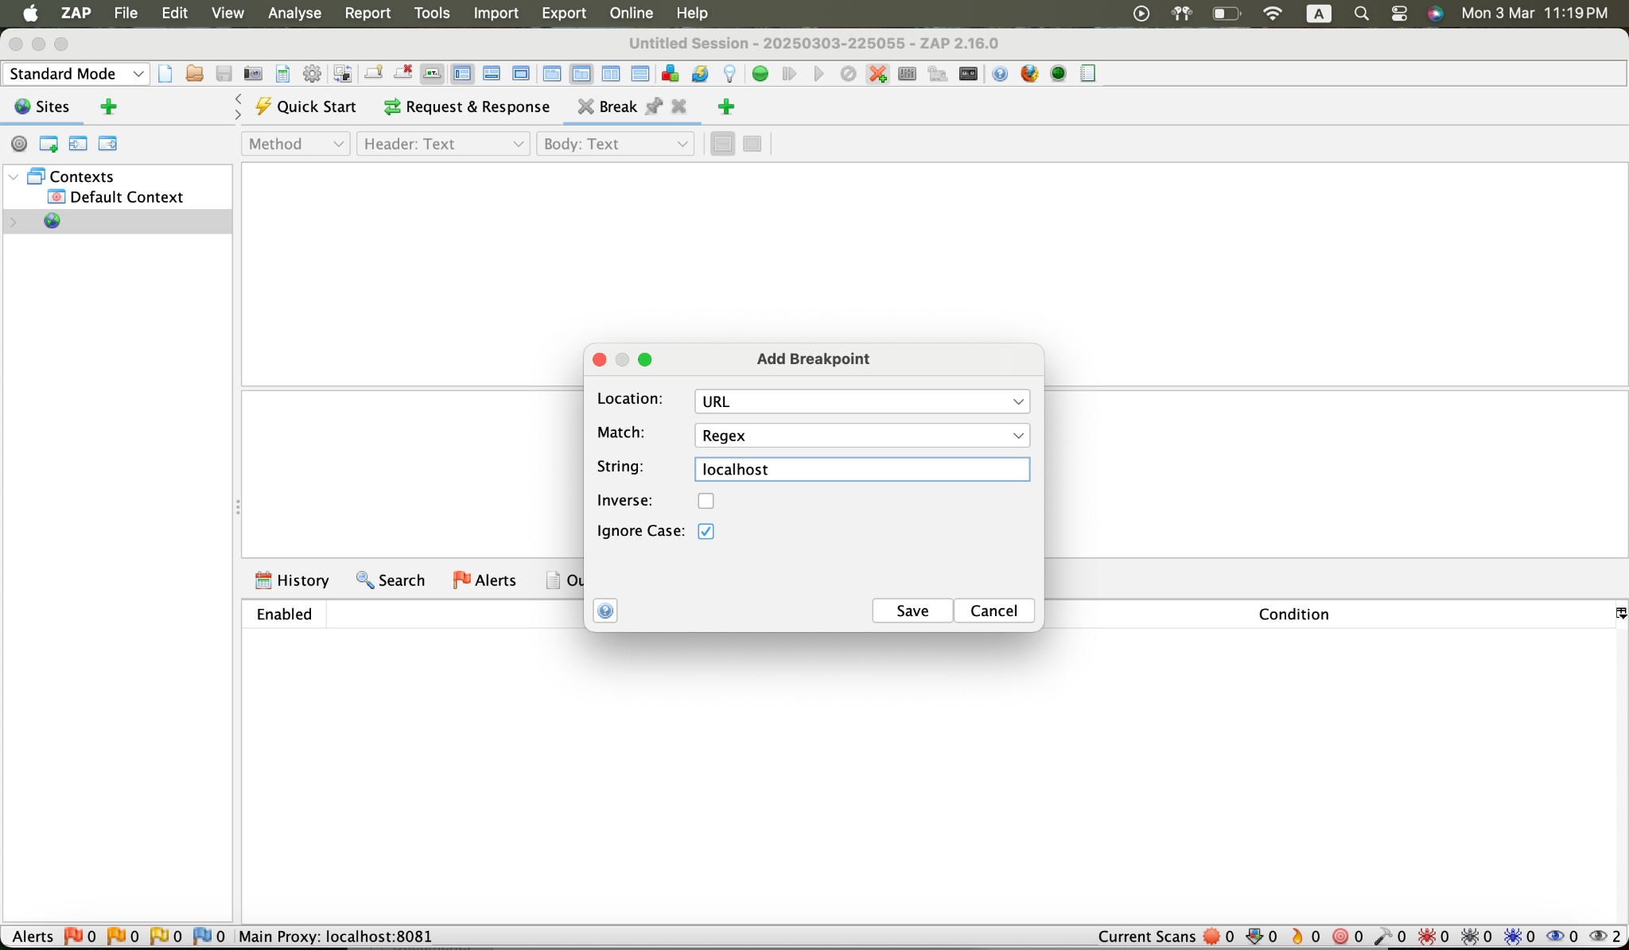

Figure 64. Adding Breakpoint

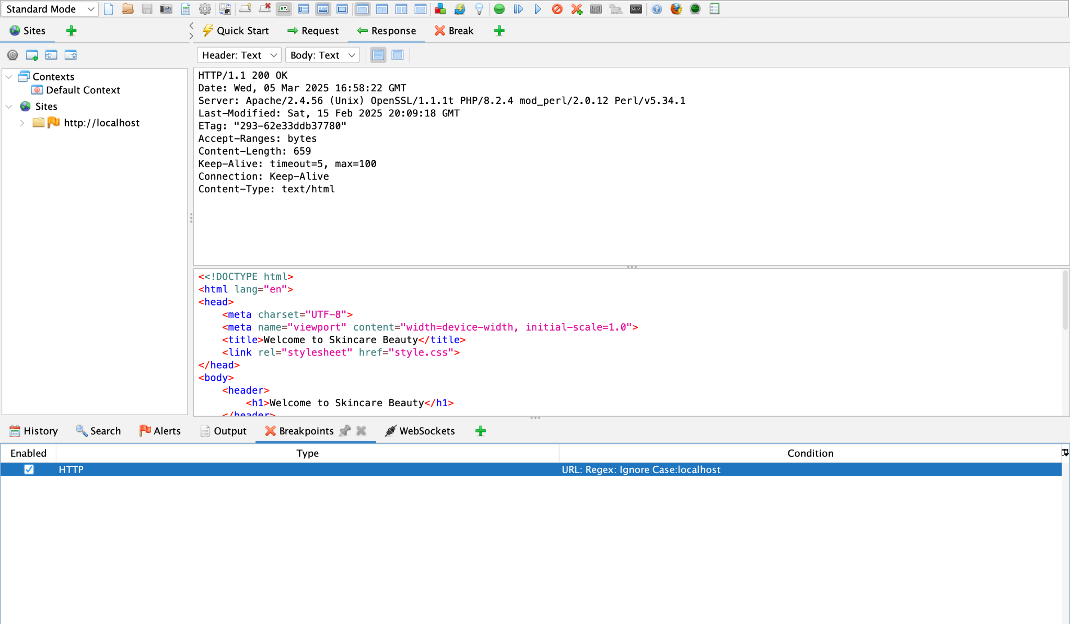

Figure 65. Localhost Site

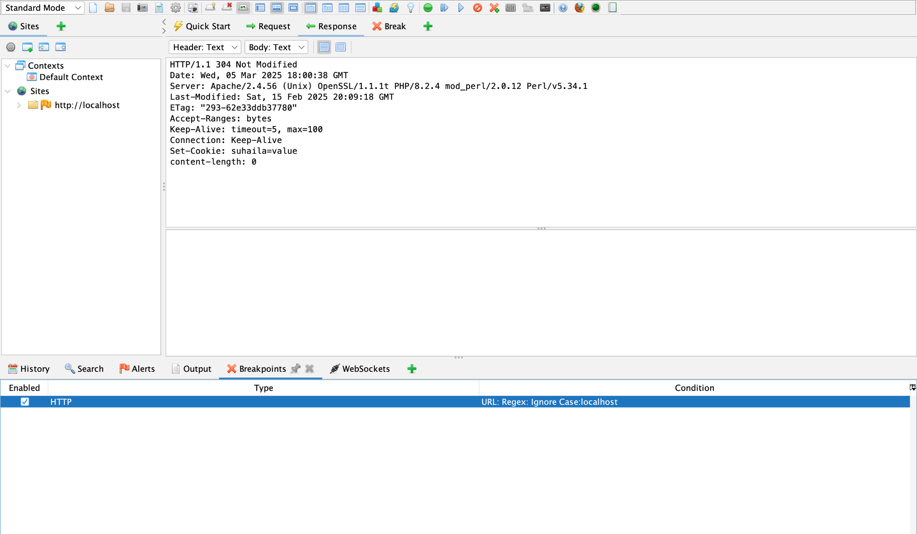

Figure 66. Setting Cookie

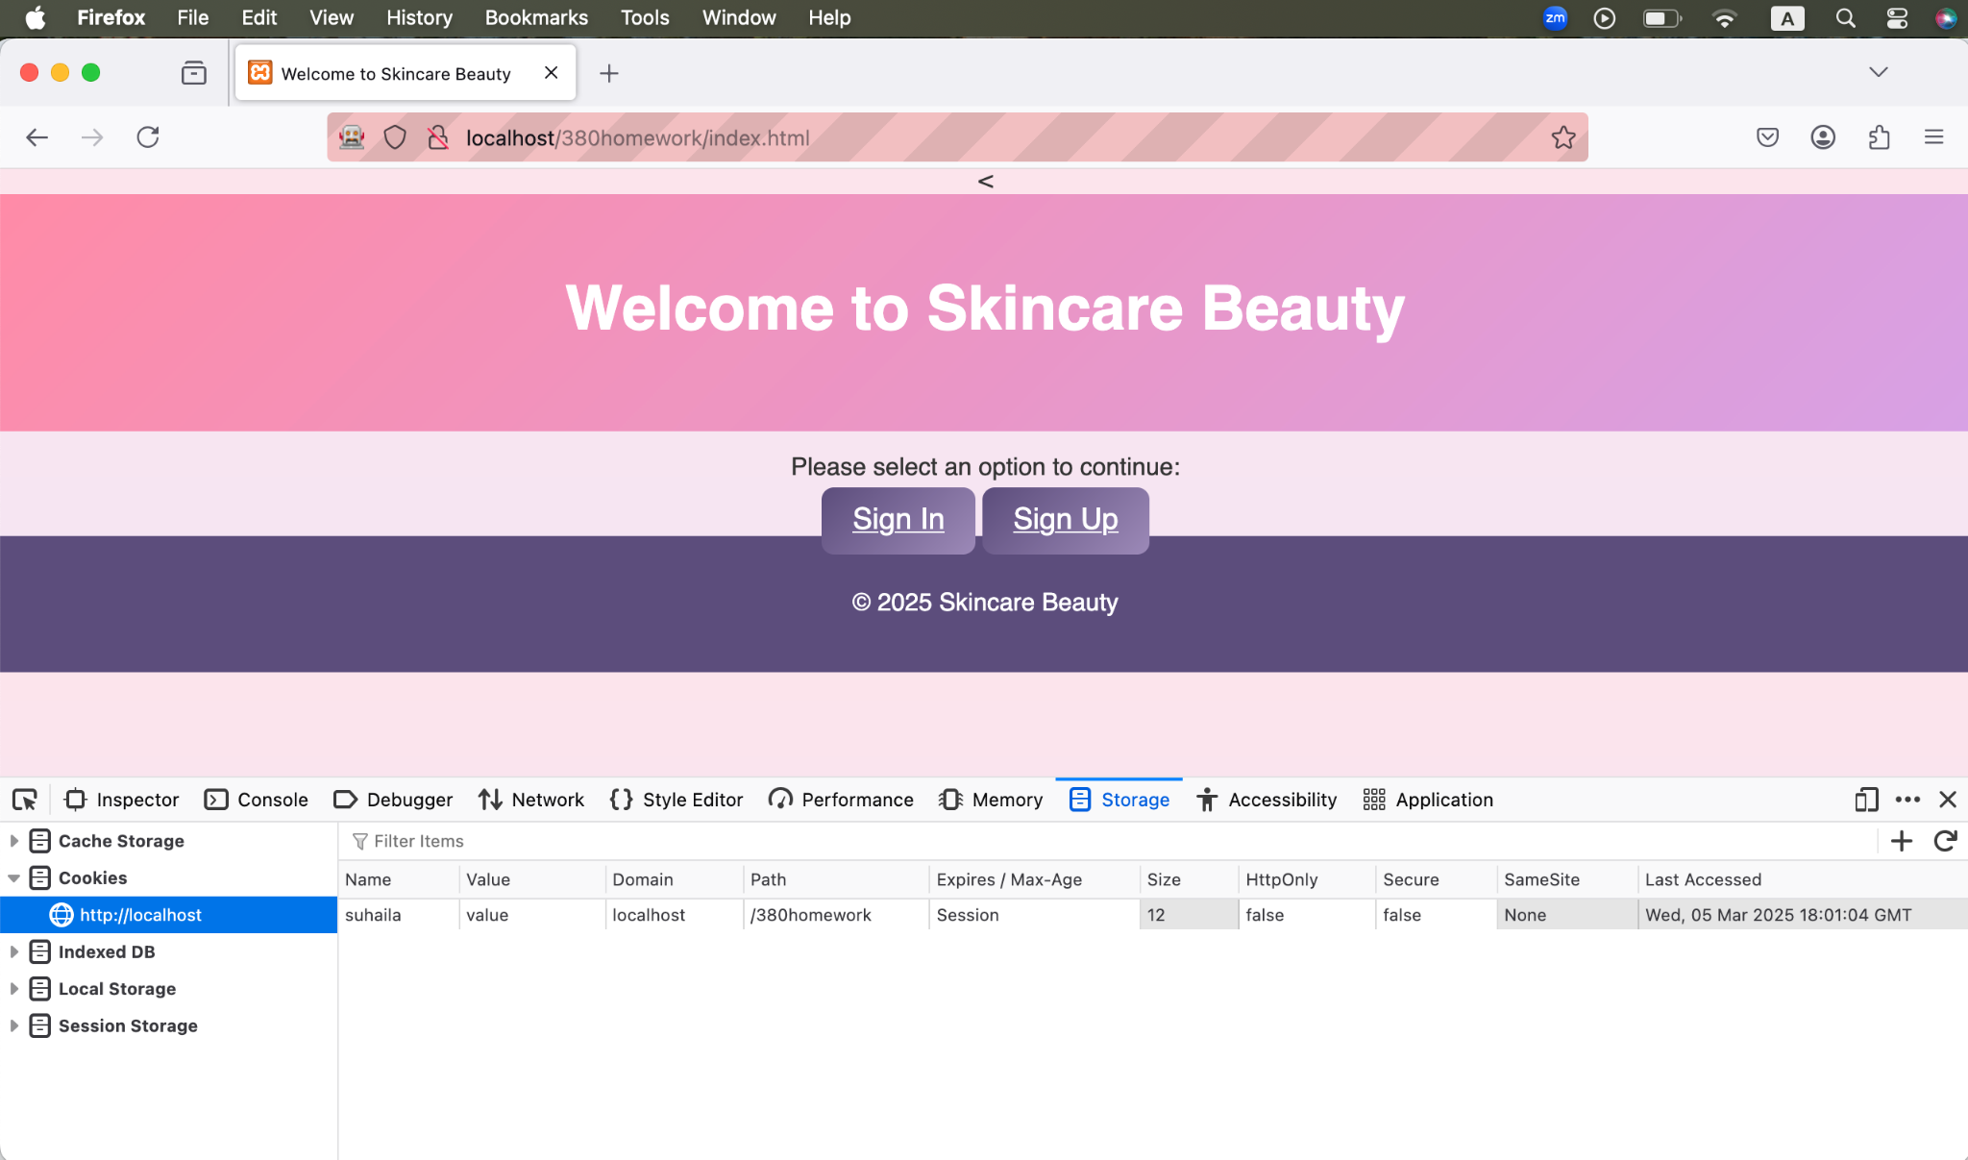

Figure 67. Firefox Cookie Storage

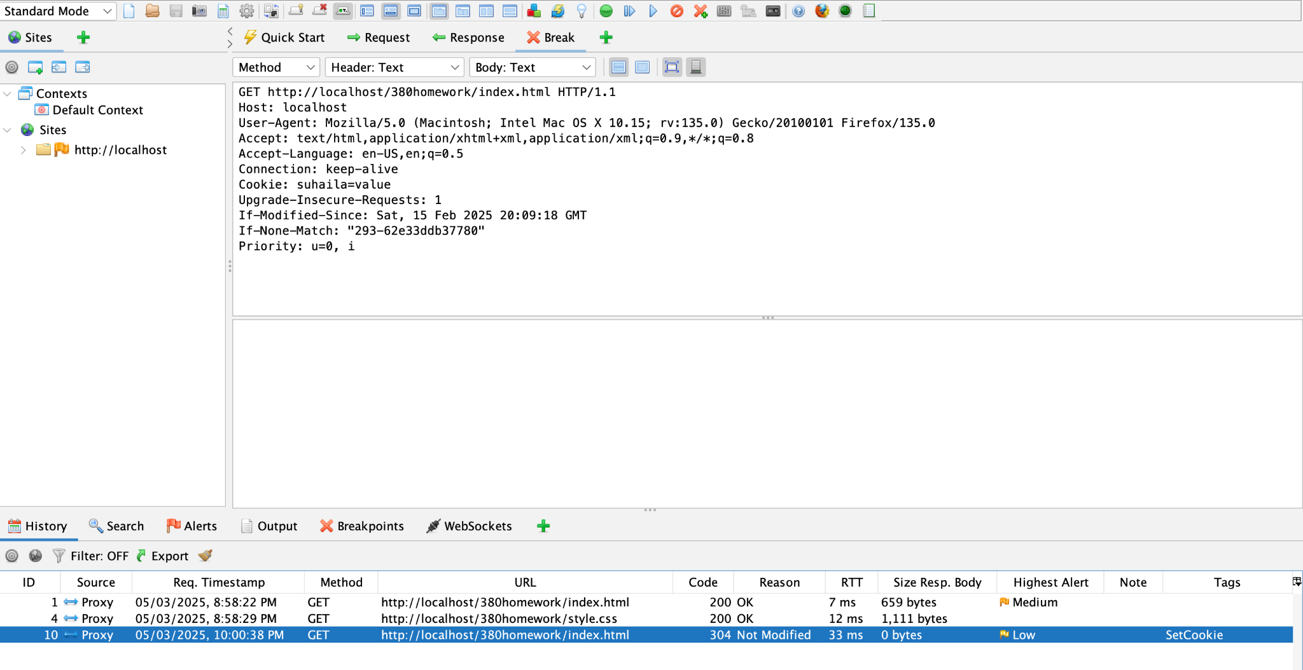Figure 68. Confirmation of the Cookie Create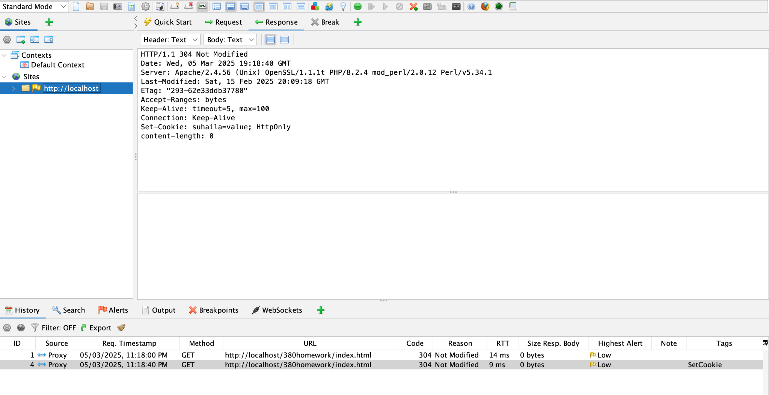Figure 69. Adding HTTPOnly header

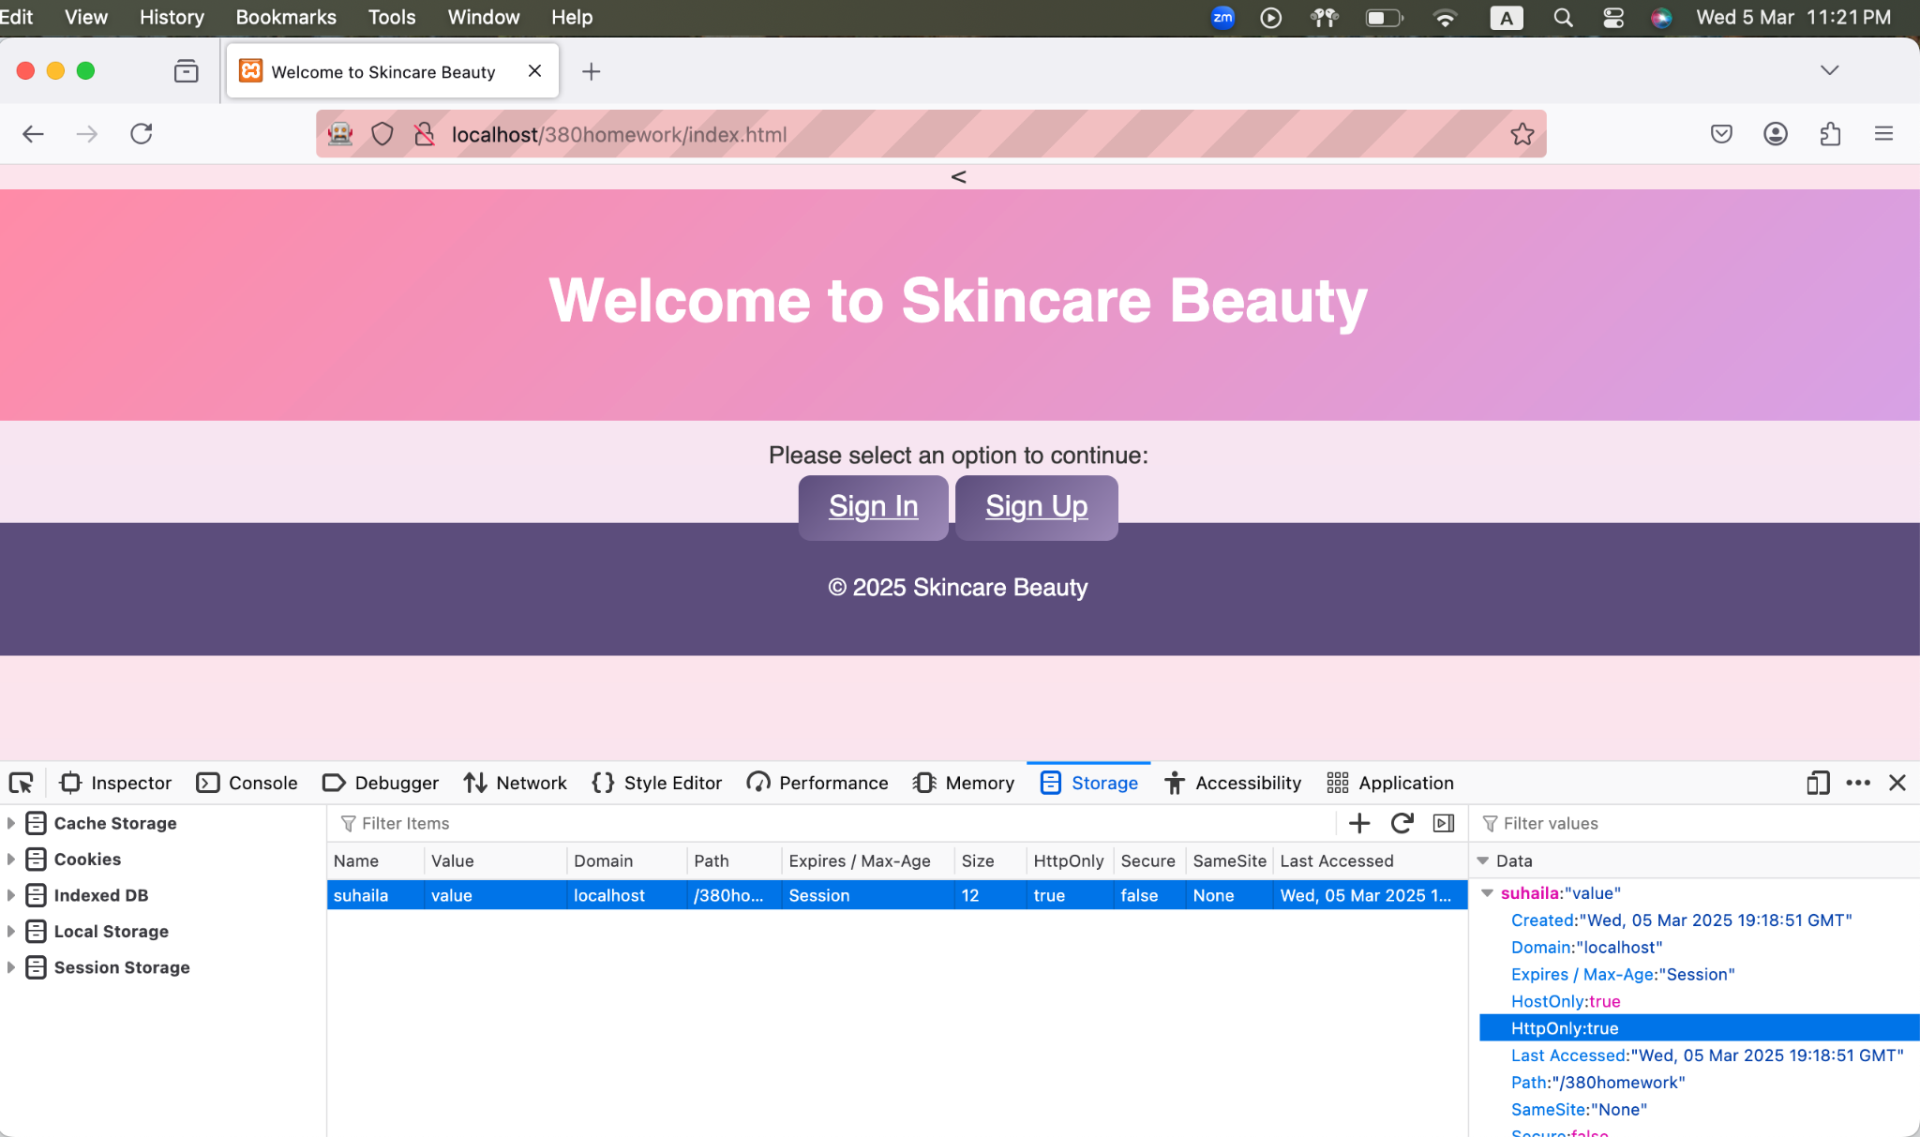

Figure 70. Confirmation of HTTPOnly header

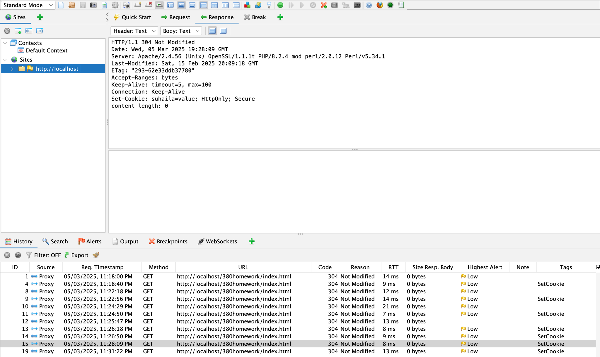

Figure 71. Adding the Secure Header

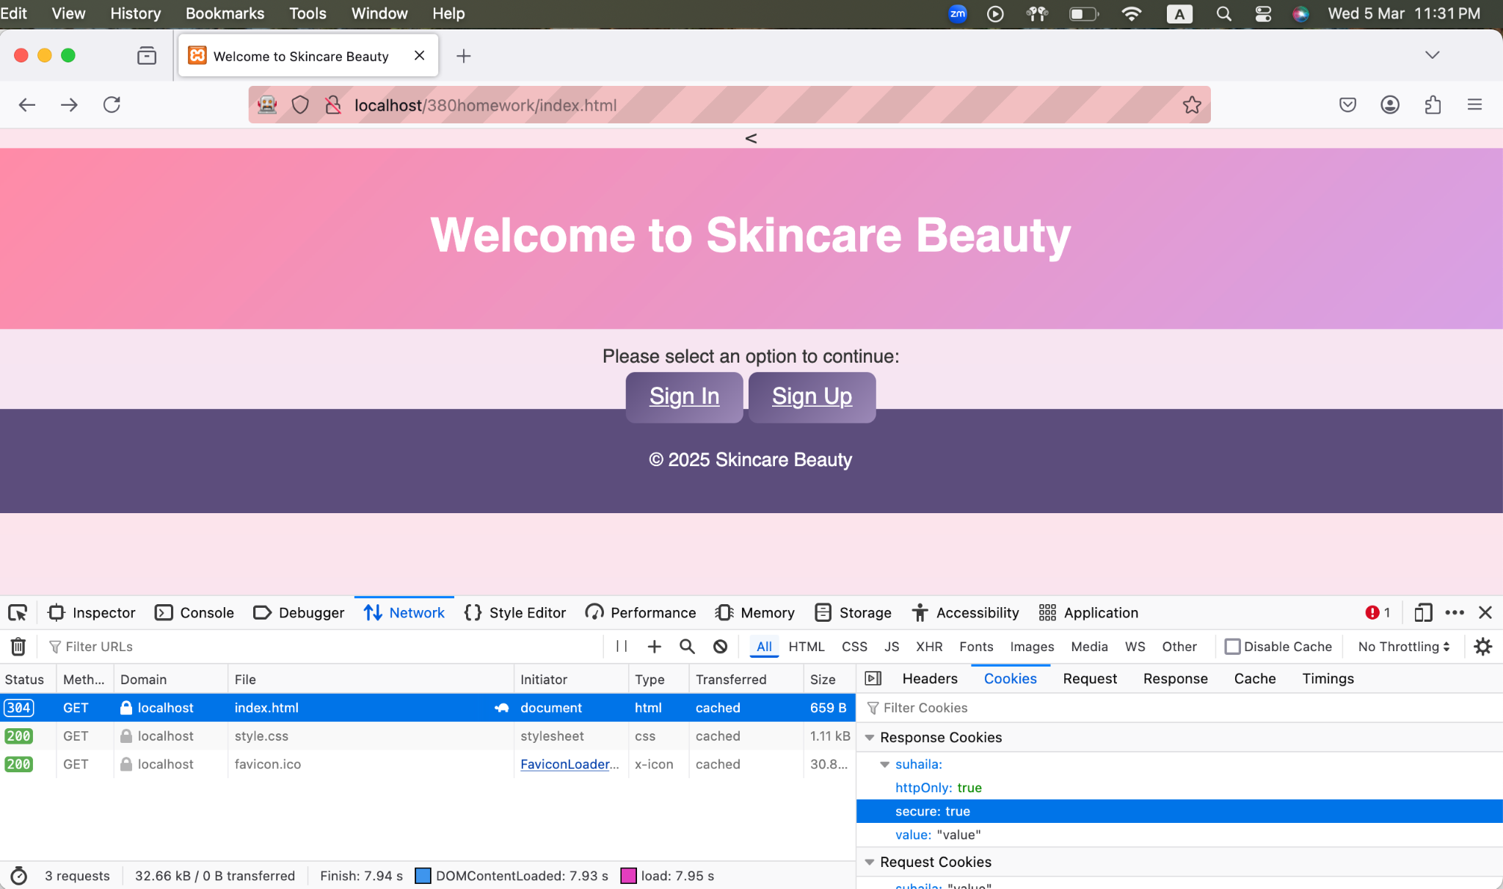

Figure 72. Confirmation the Secure Header

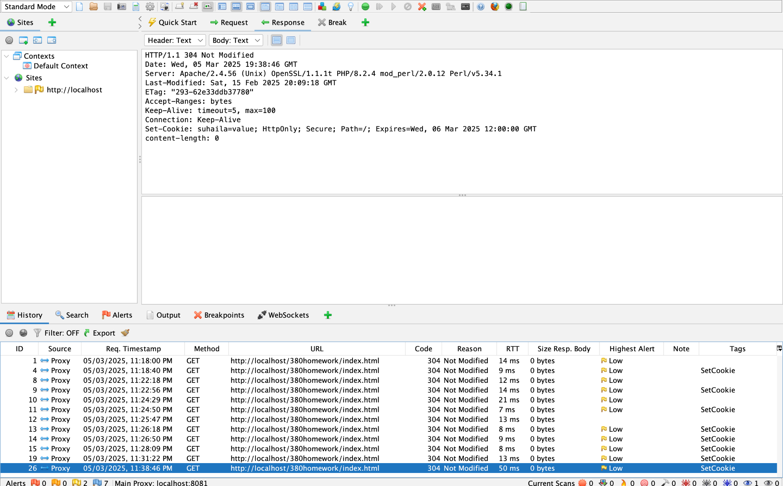

Figure 73. Adding the path and expiration

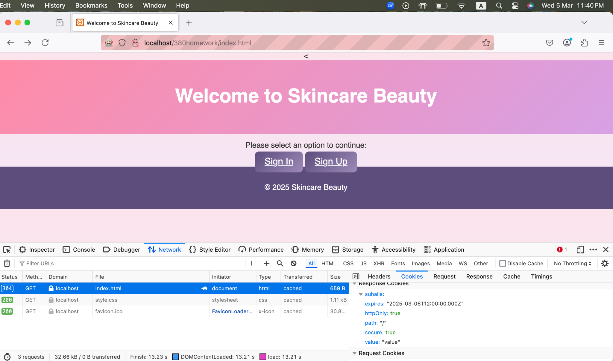

Figure 74. Confirmation of the path and expiration

The OWASP ZAP tool enables you to shape a cookie's functionality through its request interception followed by attribute transformation. OWASP ZAP lets users control cookies by adding headers including HTTPOnly for script protection, Secure for HTTPS-only transmission, Expiration Date for validity, Path for directory restrictions. The testing process lets you observe how the server manages attributes which helps discover weaknesses like scripts accessing cookies and transmitted cookies over unsecure connections.

### b. Try to set the Expiration date of the cookie to an older date than the current date.

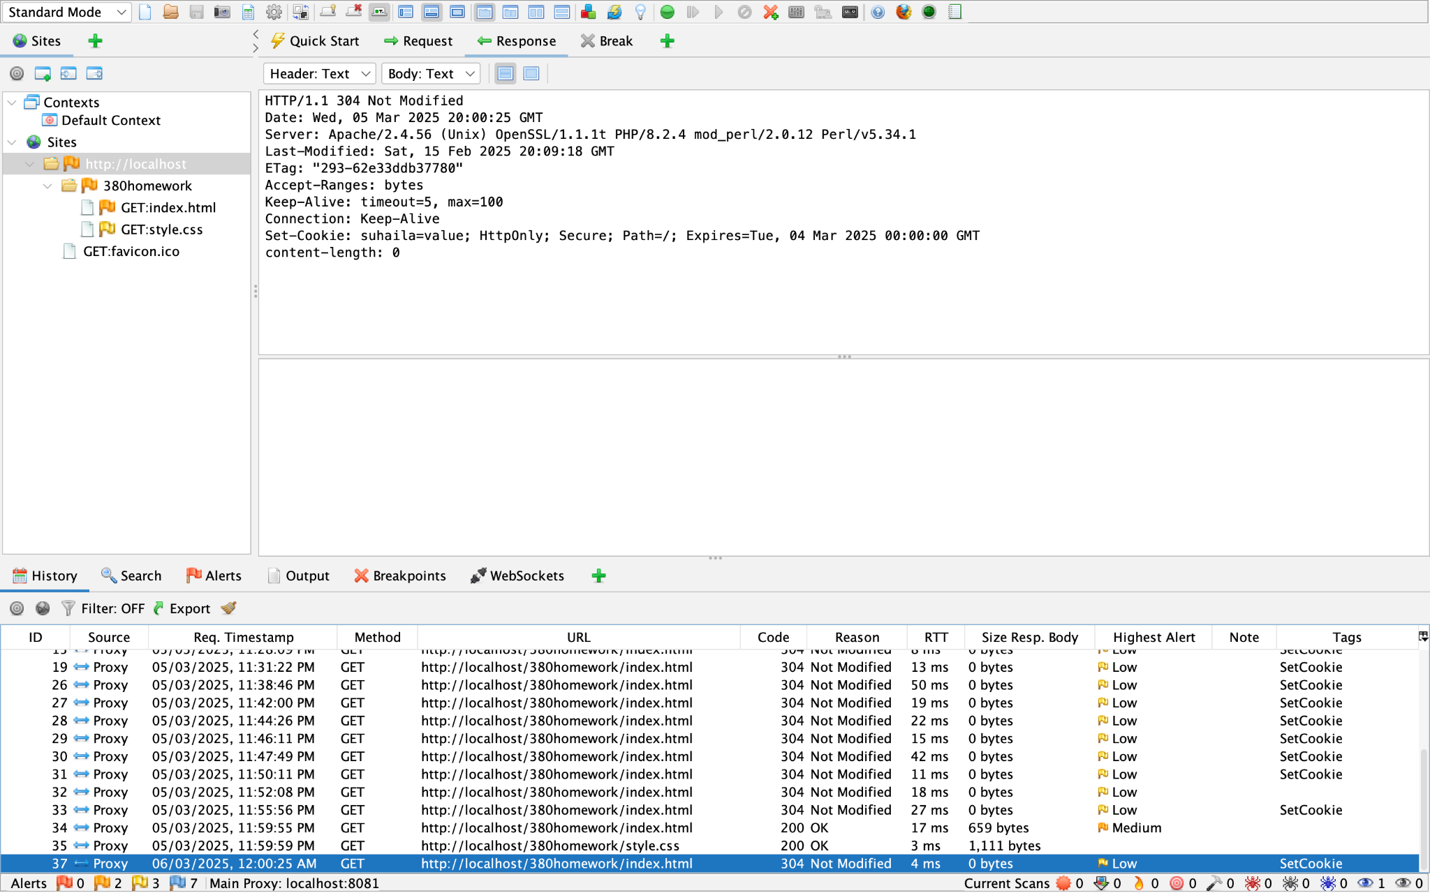

Figure 75. Setting the older expiration date

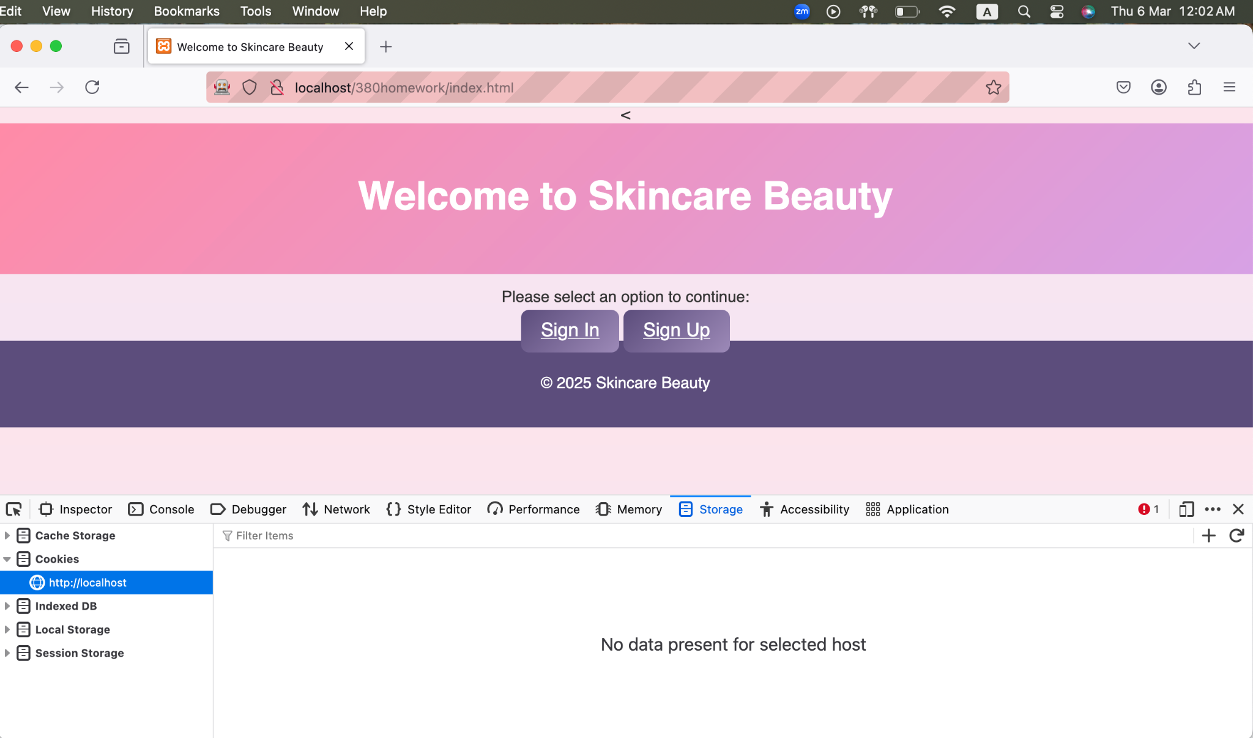

Figure 76. Confirmation of older expiration date

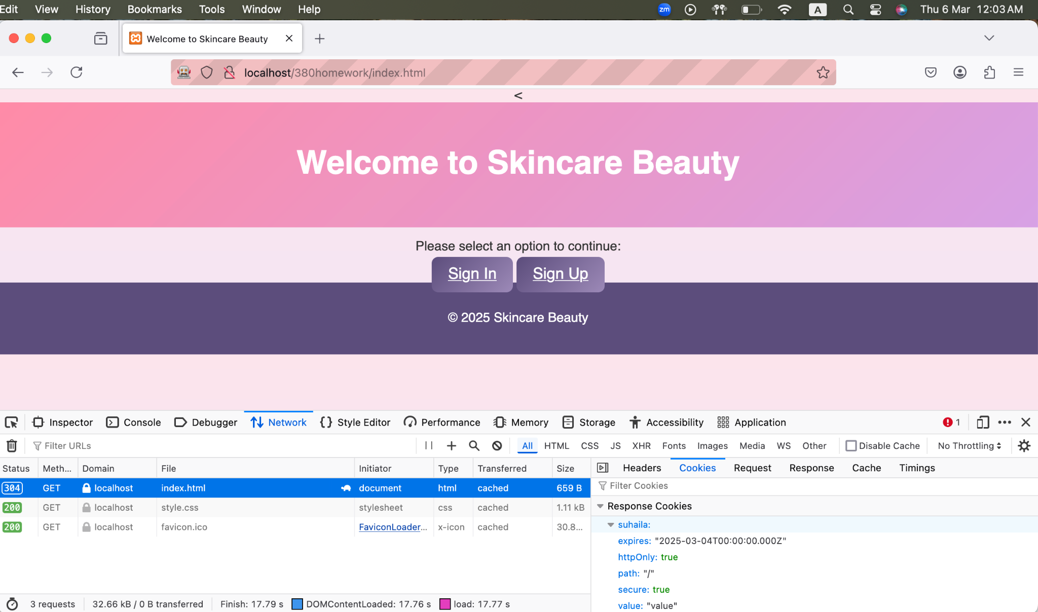

Figure 77. Confirmation of older expiration date

When setting the Expiration Date of a cookie to an older date than the current date, the browser treats the cookie as expired and it will no longer show in the cookie storage. This indicates that when the cookie expires it will immediately be deleted or ignored and as well as it will no longer be sent with future requests to the server.

## Fiddler use without installing a certificate in the browser.

### Intercept the communication between the browser where one uses HTTP and the other uses HTTPS

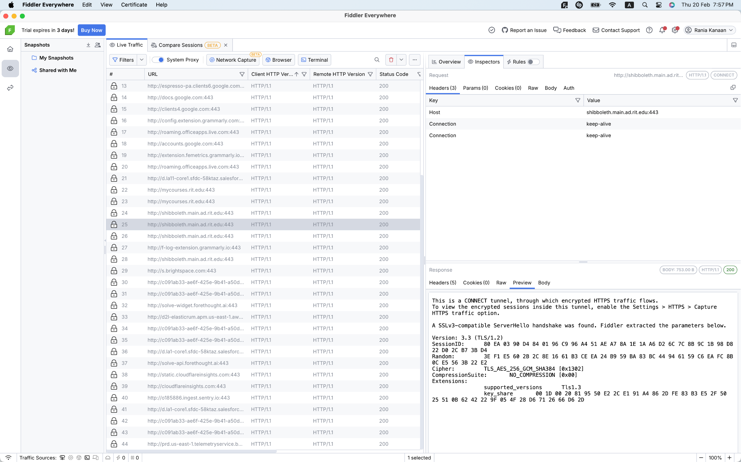

Figure 78. Secure website

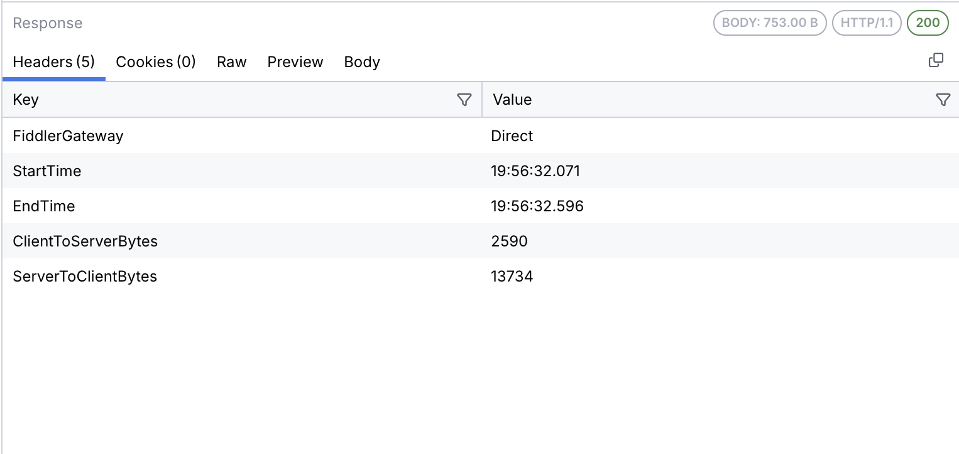

Figure 79. Response

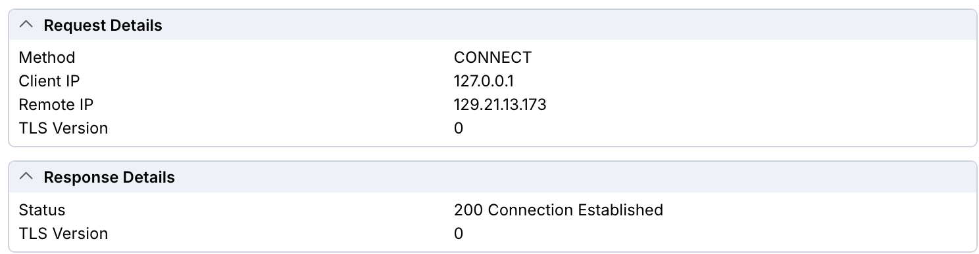

Figure 80. Request and Response Details

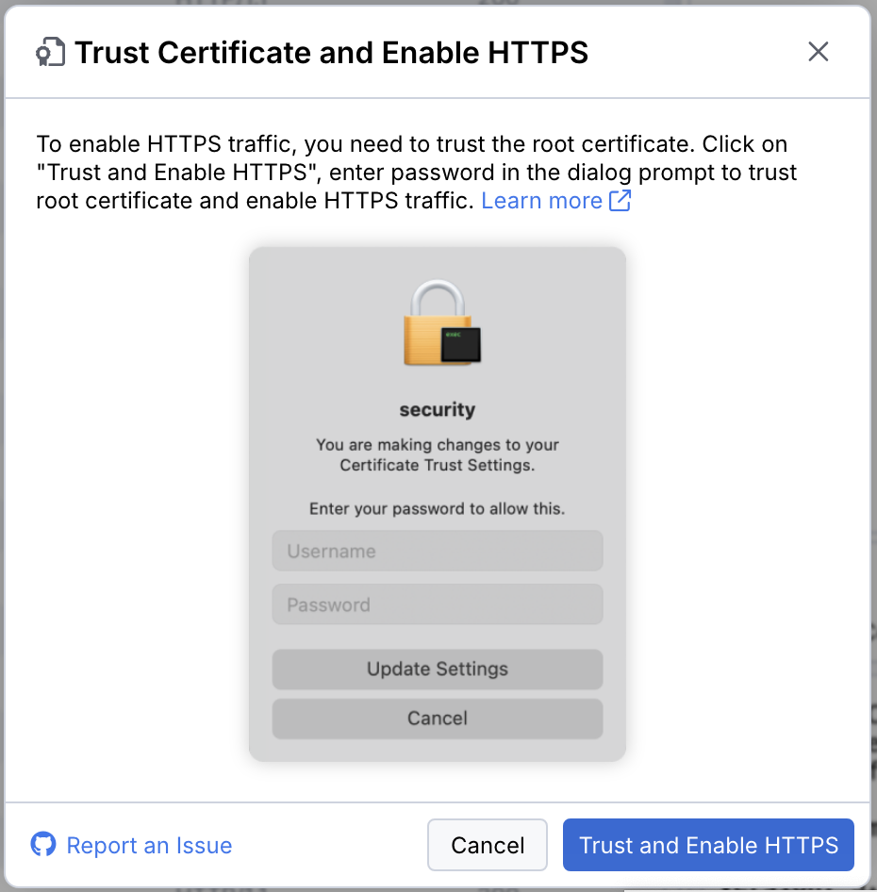

Figure 81. Trust and Enable HTTPS

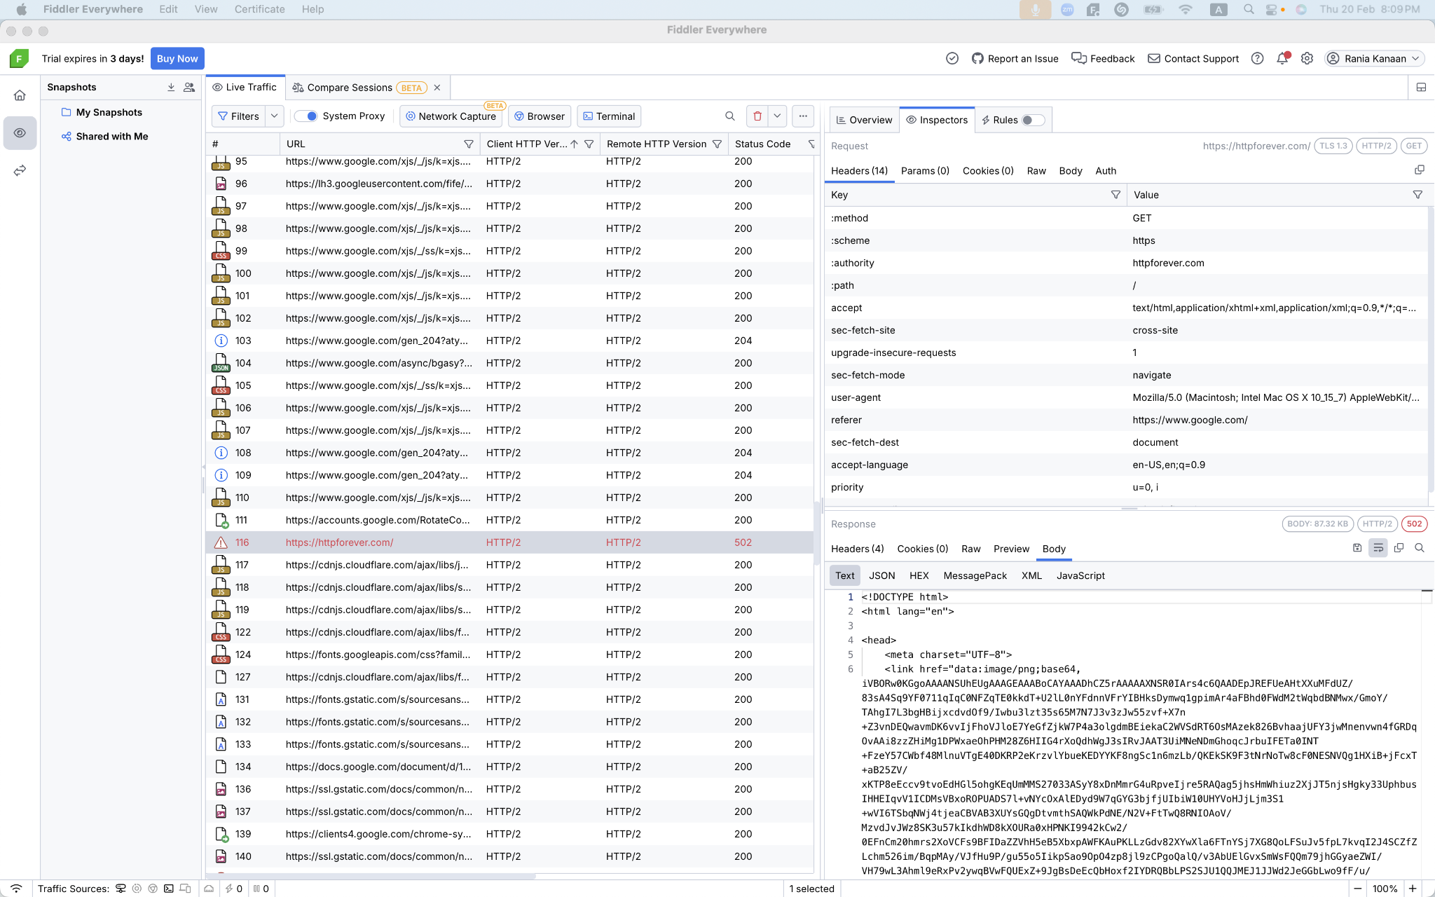

Figure 82. insecure website

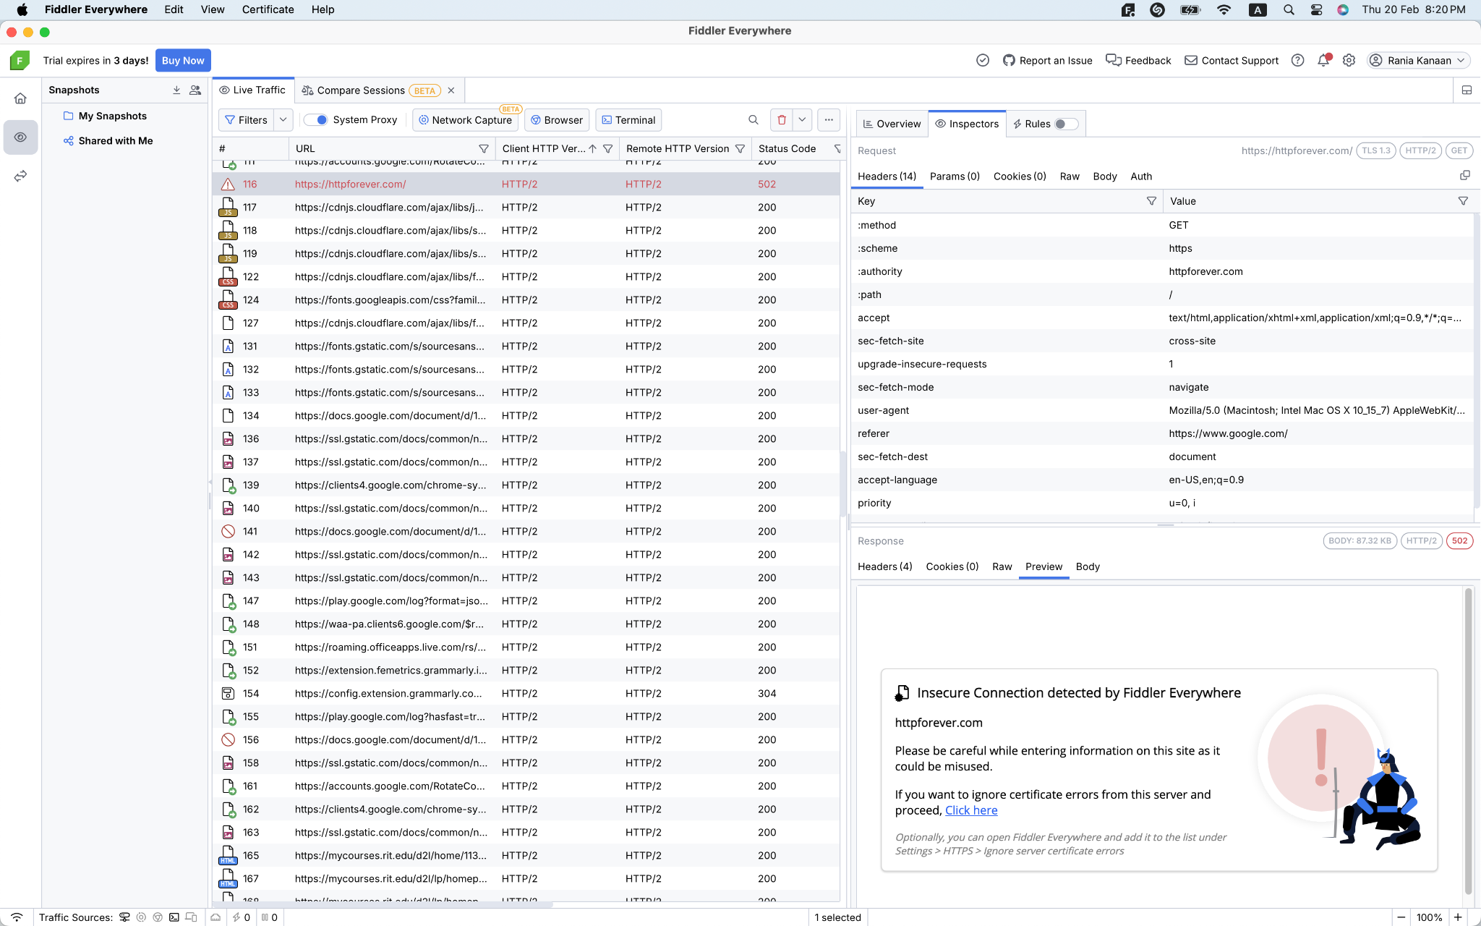

Figure 83. insecure website

**1- Communication Flow in HTTP and HTTPS:**

**HTTP:**

* Through the network a client directs their HTTP request to reach the server.
* HTTP uses clear text messaging as its information exchange method so network passages of passwords and personal data lack protection.
* The transmitted data between servers and third parties remains unguarded since an interception operation reveals complete server data.

**HTTPS:**

* A protected handshake operation occurs with shared cryptographic keys from the server and client in TLS protocol before HTTPS provides secure delivery through an established client-server communication link.
* After a CONNECT command starts the server connection the client activates TLS encryption during a secure connection setup phase.
* The encryption procedure established through client-server communication safeguards all exchanged information to such an extent that it becomes difficult for attackers to intercept communications.

**Key differences in the communication process:**

* Data encryption between agents becomes possible through the TLS handshake of HTTPS yet HTTP lacks such a process.
* Through HTTPS encryption the protocol makes an encrypted data transmission tunnel that lacks the HTTP protocol's security features.

**2- Important Headers in HTTP and HTTPS:**

1. Client Request Line:

* Client requests through both HTTP and HTTPS start with the method followed by URL information together with the HTTP version specification.
* THe URL begins with the `https://` sequence before launching with HTTPS whereas HTTP begins with `http://` at its commencement.

2. Host Header:

* The domain name targeting server requires the Host header as part of Operations.
* The server employs domain header content to enable hosting different domains through one single IP address within HTTP and HTTPS.

3. User-Agent Header:

* The User-Agent Header alerts servers to the program software that clients use as their application.
* The User-Agent header functions as a dual request element within HTTP and HTTPS operations to let servers identify their connected customers.

4. Accept Headers:

* HTTP accepts headers reveal the list of acceptable media types which includes `text/html` and `application/json`.
* Both HTTP and HTTPS servers must obtain the headers to comprehend client-intended content.

5. Connection Header:

* Clients specify their connection plan through the header by indicating active maintenance or final request handling through the header.
* Within both HTTP and HTTPS connections the `Connection: keep-alive` header remains uniformly present.
* After each transaction the header determines connection control parameters.

6. Accept-Encoding Header:

* Ahead of transmission clients submit their accepted data compression methods through the Accept-Encoding header
* This header assists both HTTP and HTTPS protocols by helping to determine the correct response compression techniques that should be used for optimizing data transfer speed.

7. Response Status Line:

* The HTTP version together with status code and status message form the response which displays as HTTP/1.1 200 OK.
* Both HTTP and HTTPS protocols provide clients with request status information through their response status lines that mark operations as successful or unsuccessful

8. Content-Encoding Header:

* A client gain instructions for body content encoding by analysing Content-Encoding fields included in an HTTP header
* The server sends compression data through this response header of both HTTP and HTTPS protocols.

9. Cache-Control Header:

* The Cache-Control header enables systems to implement caching operations that run inside both HTTP and HTTPS environments.
* The Cache-Control header should contain `no-cache` as a directive to halt sensitive data storage in cache.
* The header executes its core importance in HTTP systems and sustains its operational value for HTTPS while establishing storage requirements for resources.

10. Miscellaneous Headers:

* Also included in the response headers are three additional fields that disclose Date information along with Server details and Last-Modified timestamps of the content.

# **Observation:**

On this Homework we studied multiple security elements in web applications alongside the functions of proxy tools regarding HTTP traffic analysis and manipulation.

**Proxy Tools Functionality:** includes three tools (Burp Suite, OWASP ZAP and Fiddler) that provide powerful capabilities to intercept, analyze and alter HTTP requests and responses. Proxies enable users to monitor the unfiltered information exchanged between clients and servers that helps identify possible security issues.

**HTTP Request Manipulation:** Through Burp Suite we successfully modified HTTP GET requests by replacing the domain name and headers and by transforming the method into GET from POST. The experiment indicated how vulnerability in web applications presents risks through modification of HTTP request parameters.

**Cookie**: The ZAP tool demonstrated how cookies can be intercepted while showing practical modifications to cookies during our observations.

**HTTP vs HTTPs:** Fiddler made it possible to observe that HTTP differs from HTTPS traffic.

# **Conclusion:**

The project delivered practical web application security understanding by providing extensive training on Burp Suite and multiple proxy tool usage for examining HTTP traffic together with ZAP and Fiddler. The hands-on exercises at Melbourne Polytechnic taught students about attacker vulnerability exploitation methods through direct practice of HTTP requests modification and cookie alteration and network traffic interception. Data protection requires two essential security elements which combine secure practice coding methods with proper input validation alongside session management security because these measures ensure the protection of valuable data when HTTPS configuration is implemented. Through creating real-world imitations of web attacks in laboratory activities the team gained practical knowledge about web application safeguarding techniques. The security assignment allowed us to acquire technical proficiency by understanding how continual protection measures are needed in web development.

# **Reference**

Beschokov, M. (2024, December 28). *OWASP ZAP - ZEd Attack Proxy*. Wallarm. <https://www.wallarm.com/what/owasp-zap-zed-attack-proxy>

De Silva, S. (2021, December 31). How to configure OWASP ZAP 2.9.0 proxy and Firefox proxy and do a session recording. *Medium*. <https://samedesilva.medium.com/how-to-configure-owasp-zap-2-9-0-proxy-and-firefox-proxy-and-do-a-session-recording-ac524c4a0f1f>

*Download XAMPP*. (n.d.). https://www.apachefriends.org/download.html

Ec-Council. (2024, May 8). *BURP Suite for penetration testing of web applications*. Cybersecurity Exchange. <https://www.eccouncil.org/cybersecurity-exchange/penetration-testing/burp-suite-penetration-testing-web-application/#:~:text=Burp%20Suite%20can%20identify%20common,acts%20as%20a%20proxy%20server>.

*Installing Burp Suite Professional / Community Edition*. (n.d.). PortSwigger. <https://portswigger.net/burp/documentation/desktop/getting-started/download-and-install>

Nagendrag. (2024, January 4). *What is XAMPP?* CloudFoundation | Blog. <https://cloudfoundation.com/blog/what-is-xampp/>

Telerik. (n.d.). *Introduction - Progress Telerik Fiddler everywhere*. <https://docs.telerik.com/fiddler-everywhere/introduction#:~:text=Progress%C2%AE%20Telerik%C2%AE%20Fiddler,browser%2C%20system%2C%20or%20platform>.

*The Ultimate web debugging tool - Download Fiddler everywhere | Telerik*. (n.d.). Telerik.com. <https://www.telerik.com/download/fiddler-everywhere>

*ZAP – Download*. (n.d.). <https://www.zaproxy.org/download/>